|  |  |
| --- | --- |
| https://lh4.googleusercontent.com/8UjDB1qP9JZzOPmaFcUcfStMVZ8VpptSxvP2gLI4YEgiQjYcR_cNonqtNuPXhrQgV8bh6KhEcLSyw65PBxk4I_MmEGS12guoUS4zmc4dB_Rpw37rALtJJ1pTRzylHuZjGbOKaMo | **FPT ACADEMY INTERNATIONAL**  **FPT – APTECH COMPUTER EDUCATION** |

**Centre Name: ACE-HCMC-2-FPT.**

**Address: 590 Cach Mang Thang 8, District 3, Ho Chi Minh City, Viet Nam.**

**Game Gear**

|  |  |  |
| --- | --- | --- |
| **Supervisor.** | **Lê Mộng Thuý** | |
| **Batch.** | **T1.2108.A0** | |
| **Group.** | **Group 1** | |
| **Serial No.** | **Student Name** | **Enrollment Number** |
| **1.** | **Nguyễn Lê Thuận** | Student1322490 |
| **2.** | **Huỳnh Ngọc Thái** | Student1317113 |
| **3.** | **Ngô Hạnh Dung** | Student1328426 |
| **4.** | **Nguyễn Trần Trọng** | Student1328431 |
| **5.** | **Trần Công Thịnh** | Student1331708 |

Month 06 Year 2022

**CONTENT**

REVIEW 1 3

ACKNOWLEDGE 3

INTRODUCTION 3

PROBLEM DEFINITION 4

CUSTOMER'S REQUIREMENTS SPECIFICATIONS (CRS) 4

CLIENT 6

TASK SHEET REVIEW 1 8

REVIEW 2 9

USECASE 9

DATA FLOW DIAGRAM (DFD) 39

ENTITY PROPERTIES 46

ENTITY RELATIONSHIP DIAGRAM (ERD) 58

TABLE DESIGN 59

TASK SHEET REVIEW 2 64

REVIEW 3 65

SITE MAP 65

GAME GEAR WIREFRAME 67

TASK SHEET REVIEW 3 77

# 

# **REVIEW 1**

## ACKNOWLEDGE

Our group would like to devote this chapter to express our sincere appreciation to all those who offered us valuable assistance during in carrying out this Project.

Firstly, we owe a debt of gratitude to our dedicated instructor, MS. Le Mong Thuy, whose suggestions and encouragement helped us to overcome not only technological challenges but also psychological tension. Without him, our work could not complete successfully.

Secondly, we highly appreciate the Project Team at the Head Office, which has provided us an excellent opportunity to apply what we learned into practice. We are certain that the experiences we gained from this project will facilitate our future career greatly.

Thirdly, we would also like to express my gratitude to all the staff members of my center for not only providing me with the opportunity to work with them on this project, but also for their support and encouragement throughout the process.

Finally yet importantly, we wish to say a personal thank you to all our dear classmates and team members who are always willing to support us openly and enthusiastically.

## INTRODUCTION

We are in an age when information technology makes buying and selling easier than ever. People can order an expensive phone for an everyday kitchen appliance and everything is done electronically and interacting in real time. Game equipment are also not out of this cycle. So we are developing a website called Game Gear to provide easy access to buying all kinds of game accessories and gaming device online.

Game Gear is for an organization who wants to develop an online store where the visitor can be a person who does not have much time to go to the wine store or person has shopping online habit or just simply they stay too far from standalone store. It will provide its user the following features.

For Game Gear customer base:

* Unregistered visitor who can register member account.
* Registered visitor can login and manage their account.
* Customer can search any products such as monitor, headset, mouse, keyboard, speaker,…
* Customer can search products by price.
* Customer can see products’ introduction before buying.
* Customer can buy products after adding products to cart.
* Customer can view cart history.

Visitors can interact with website by giving question, feedback on contact us function.

## PROBLEM DEFINITION

After analyzing the project specifications of Game Gear, to fulfil customer’s requirements properly, we came to conclusion that in order to achieve the best result, we should deal with following queries:

#### FROM THE VIEW POINT OF CUSTOMER

* A homepage will show the main products, suitable logo, display the logo on all the pages in the site.
* A navigation header and footer that will include all the functions implemented in the website.
* Visitors just can see products, add product to cart, view cart but viewers who want to checkout are required to register.
* Registered visitors can login to their profile, view order history and receive email promotion/Coupon, products, add product to cart, view cart and checkout.

#### FROM THE VIEW POINT OF THE ADMINISTRATOR

* A login page will grant access to Game Gear admin.
* Admin can view, add, update, delete, manage orders and manage products find, lock, and unlock customer account.
* Admin can update, or delete and manage registered user account.
* Admin can manage and send newsletter.
* Admin can register and assign role to staff users.

## CUSTOMER'S REQUIREMENTS SPECIFICATIONS (CRS)

#### CLIENT: GAME GEAR

BUSINESS/PROJECT OBJECTIVE:

The project is to design an online website for advertising and selling all types of game equipment: monitor, headset, mouse, keyboard, speaker,…

INPUT TO THE SYSTEM:

Game Gear administrators need to provide:

* Information required in order creating account to access to the admin system.
* Products are going to be shown on the website.
* Payment Method and Shipping cost when ordering certain product.
* Information required to create staff account within admin system.

Customers Game Gear need to provide:

* Personal information to buy products.
* Email information to receive weekly promotion or deal and coupon.

OUTPUT FROM THE SYSTEM:

Game Gear administrators will be able to:

* Login/Logout to the admin system.
* Product management (view, add, update, delete, hidden) products, price, promotion.
* Product management (view, add, update, delete, find, lock, unlock) customer account.
* News management (view, add, update, delete) news.
* Product management (view, add, update) products, order.

Game Gear guests registered will be able to:

* Register customer account.
* Buy products after add information.
* View products that they have chosen.
* View order history.

Game Gear customer will be able to:

* Register account.
* Login/Logout to the account.
* Search products they want to buy by name, price.
* Add product to cart and checkout.
* View purchase history.

#### SCOPE OF WORK

The application should perform the following functions:

LOGIN:

* There are 2 types of account in the application. Administrator will login a “Admin”,“Member”
* For “admin”: can view the products id, name, add new, update, delete.
* For “admin”: can view the customer id, name, add new, update, delete, lock, unlock.
* For “admin”: can view and manage order.
* For “member” : can only view, add and delete products in carts, product management, product reviews, payments, and view purchase history.

ORDERING PRODUCTS:

* When customer choose a product and the selected product will be added to the cart.
* Customer can buy products at shopping cart after pressing the “Checkout” button and fill in the information.

DATABASE:

* The information about products, customers, news, orders will be stored in the database.

The information from the contact us page.

#### HARDWARE/ SOFTWARE REQUIREMENTS:

HARDWARE

Web Server

|  |  |
| --- | --- |
| **Processor** | Intel Core I7 or higher. |
| **Memory** | 32 GB RAM or greater. |
| **Modem/ADSL** | Internet access is required. |

## CLIENT

|  |  |
| --- | --- |
| **Processor** | Intel Core I5 or higher. |
| **Memory** | 8 GB RAM or greater. |
| **Monitor** | Super VGA (1024x768) or higher resolution. |
| **Modem/ADSL** | Internet access is required. |

SOFTWARE

Web Server

|  |  |
| --- | --- |
| **Operation System** | Window 7 or later. |
| **Browser** | Google Chrome version 35. |
| **Database** | MySQL. |
| **Software** | Internet Information Service |
| PHP - Laravel framework |

Client

|  |  |
| --- | --- |
| **Operation System** | Window 7 or higher. |
| **Browser** | Google Chrome version 35. |

DEVELOPMENT SOFTWARE

* Microsoft Windows 10.
* MySQL.
* Visual Studio Code.
* Google Chrome.
* XAMPP.

TECHNOLOGY

* PHP - Laravel framework.
* JQuery.
* Javascript.
* HTML/CSS/Bootstrap.

# *TASK SHEET REVIEW 1*

|  |  |  |  |  |  |  |  |  |
| --- | --- | --- | --- | --- | --- | --- | --- | --- |
| **Project: Game Gear** | | **Project**  **Name** | **Activity**  **Plan**  **Prepared By** | | **Date of Preparation of Activity Plan:** | | | |
| **Sr./No.** | **Task** | **Actual**  **Start**  **Date** | **Actual Days** | **Team** **member** **name** | **Status** |
| **1.** | **Acknowledgment** | **Game Gear** | Trọng | | 08-Jun-22 | 1 | Trọng | Completed |
| **2.** | **Introduction** | 08-Jun-22 | 1 | Thuận | Completed |
| **3.** | **Problem Definition** | 08-Jun-22 | 1 | Trọng | Completed |
| **4.** | **Customer**  **Requirement**  **Specification (CRS)** | 08-Jun-22 | 1 | Thuận/Trọng | Completed |
| **5.** | **Scope of Work** | 08-Jun-22 | 1 | Thuận/Trọng | Completed |
| **6.** | **Hardware/Software Requiement** | 08-Jun-22 | 1 | Trọng | Completed |
| **7.** | **Task Sheet** | 08-Jun-22 | 1 | Trọng | Completed |
| Date: 08 JUNE 2022 | | | | | | | | |
| **Signature of Instructor:**  **Ms.LE MONG THUY** | | | | **Signature of Team Leader:**  **NGUYEN TRAN TRONG** | | | | |

# **REVIEW 2**

## **USECASE**

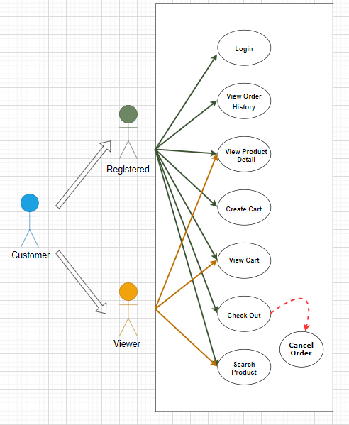

CUSTOMER

LOGIN AS CUSTOMER:

|  |  |  |
| --- | --- | --- |
| **Author** |  | |
| **Use Case Name** | Login | |
| **Actors** | Customer | |
| **Description** | Customer who has registered an account can login | |
| **Requirements** | Customer provides username and password | |
| **Pre-conditions** | Customer must register an account | |
| **Post-conditions** | Success: Visitor is logged in to website | |
| Fail: Refill information | |
| **Basic flow** | **Actor’s actions:** | **System’s responses:** |
| 1. Visitor clicks ‘Login’ button on Home Page.        3. Actor inputs Email and Password, then click the ‘Login’ button. | 2. System redirects to Login Page with the following controls: - “Email” text field   * “Password” text field * “Login” button  1. System checks the information. 2. System redirects to Customer’s dashboard. |
| **Exceptions** | **Actor’s actions:** | **System’s responses:** |
| 1. Actor inputs invalid email and password. | System redirects to Login page with the following controls: - “Email” text field |
|  |  | * “Password” text field * “Login” button   System shows message: “Invalid email and password”. |

REGISTER AS VISITOR:

|  |  |  |
| --- | --- | --- |
| **Author** |  | |
| **Use Case Name** | Register as Visitor | |
| **Actors** | Customer | |
| **Description** | Customer who has registered an account can login | |
| **Requirements** | Customer registers an account on the website and becomes a member | |
| **Pre-conditions** | Customer provides their register information | |
| **Post-conditions** | Success: Visitor creates a User account in this website | |
| Fail: Refill information | |
| **Basic flow** | **Actor’s actions:** | **System’s responses:** |
| 1. Visitor clicks “Register” button on Home Page. | 2. System redirects to Register page and displays Registration form with the following controls:   * “Username” text field * “Password” text field * “Confirm Password” text field * “Email” text field |

SEARCH PRODUCTS:

|  |  |  |
| --- | --- | --- |
| **Author** |  | |
| **Use case name** | Search product | |
| **Actors** | Registered Customer/ New Customer | |
| **Description** | Customer can search product | |
| **Requirements** | Customer provides search phrase | |
| **Pre-conditions** | N/A | |
| **Post-conditions** | Success: Show product that matches search phrase | |
| Fail: No product is shown | |
| **Basic flow** | **Actor’s actions:** | **System’s responses:** |
| 1. Actor inputs search phrase.  3. Actor clicks product’s name in list or view every product that matches search phrase. | 2. System shows list of products that match the search phrase. |

VIEW PRODUCT DETAIL:

|  |  |  |
| --- | --- | --- |
| **Author** |  | |
| **Use case name** | View product | |
| **Actors** | Registered Customer/ New Customer | |
| **Description** | Customer can view product detail | |
| **Requirements** | Customer select product to show product’s detail | |
| **Pre-conditions** | N/A | |
| **Post-conditions** | Success: Display product detail matching the selected product | |
| Fail: No product is shown | |
| **Basic flow** | **Actor’s actions:** | **System’s responses:** |
| 1. Actor select product | 2. System shows product’s detail matching selected product |

CREATE CART:

|  |  |  |
| --- | --- | --- |
| **Author** |  | |
| **Use case name** | Create cart | |
| **Actors** | Registered customer | |
| **Description** | Customer can add product to their cart | |
| **Requirements** | Customer must choose at least one product | |
| **Pre-conditions** | Customer must log in before adding product | |
| **Post-conditions** | Success: Actor add product to cart successfully | |
| Fail: Refill information | |
| **Basic flow** | **Actor’s actions:** | **System’s responses:** |
| 1. Actor chooses a product and click “Add to cart”. | 2. System adds selected product to cart by id of this product. |
| **Exceptions** | **Actor’s action** | **System’s response** |
| 1. Actor inputs more products than there are in stock. | 2. System shows messages:  - “Product out of stock”. |

VIEW CART:

|  |  |  |
| --- | --- | --- |
| **Author** |  |  |
| **Use case name** | View cart |  |
| **Actors** | Registered customer |  |
| **Description** | Customer can view their cart |  |
| **Requirements** | N/A |  |
| **Pre-conditions** | Customer must log in before view cart |  |
| **Post-conditions** | Success: Customer can view their cart |  |
| Fail: Refill information |  |
| **Basic flow** | **Actor’s actions:** | **System’s responses:** |
| 1. Actor click on “Cart” icon. | 2. System shows cart and added products. |
| **Alternative flow** | 1. Actor clicks “x”– Close button- on table  3. Actor change quantity of a product  5. Actor clicks “x” – close button – in the right side of each product. | 2. System redirects to current page.  4. System update quantity of this product into cart.  6. System removes this product from cart. |

CHECKOUT:

|  |  |  |
| --- | --- | --- |
| **Author** |  | |
| **Use case name** | Check out and Place order | |
| **Actors** | Registered customer | |
| **Description** | Customer can order products | |
| **Requirements** | Customer must has at least 1 product in cart | |
| **Pre-conditions** | Customer must log in before adding product | |
| **Post-conditions** | Success: Actor order successfully | |
| Fail: Refill information | |
| **Basic flow** | **Actor’s actions:** | **System’s responses:** |
| 1. Actor click “Add to cart” button or “Cart” icon.  3. Actor clicks “Check out with” button.   1. Actor inputs order information then click “Place Order” button. 2. Actor inputs Card owner’s name, card number and security code if actor choose payment by credit card.   9. Actor views order’s status in Order page. | 2. System shows cart and added products.  4. System shows all products in cart with calculated total price and show following controls:   * “Customer name” text field. * “Phone” text field. * “Address” text field. * “Province” select box. * “Delivery time frame” select box. * “Payment” table.   Systems shows Payment tab type according to type of payment actors choose. |
|  |  | 1. System validates information. 2. System redirects to Order page and show order’s status. |
| **Alternative flow** | 1. Actor clicks “x”– Close button- on table  3. Actor clicks “X” button on each product.  5. Actors clicks “Home” button. | 2. System redirects to cart page.  4. System removes product from cart.  6. System redirect to Home pages. |
| **Exceptions** | **Actor’s action** | **System’s response** |
| 1. Actor inputs more products than there are in stock. 2. Actor left “Billing name” text field blank. 3. Actor left “Address” text field blank. 4. Actor left “Delivery date” blank. 5. Actor left “Delivery time frame” blank. 6. Actor left “Payment” dropdown blank. 7. Actor inputs invalid card information. | 8. System shows messages:   * “Product out of stock”. * “Order name must not be blank”.   “Address must not be blank”.  “Must choose a delivery date”.  “Must choose a delivery time frame”.  “Must choose a payment method”.  “Invalid card”. |

VIEW ORDER HISTORY:

|  |  |  |
| --- | --- | --- |
| **Author** |  | |
| **Use case name** | View order history | |
| **Actors** | Registered customer | |
| **Description** | Customer can view their order history |  |
| **Requirements** | N/A |  |
| **Pre-conditions** | Customer must log in to website |  |
| **Post-conditions** | Success: Customer can view their order. |  |
| Fail: Customer cannot see their order. |  |
| **Basic flow** | **Actor’s actions:** | **System’s responses:** |
| 1. Actor chooses “Account” icon on Menu  3. Actor chooses “Purchase history” on sides bar.  5. Actor selects the order that they want to view in “Purchase history” and clicks “View” Button. | 2. System redirects to Account page.  4. System redirects to “Purchase history” page and displays a list of existing orders and their status.   1. System validates inputs by id of Order. 2. System displays all order’s detail and its status. |

CANCEL ORDER:

|  |  |  |
| --- | --- | --- |
| **Author** |  | |
| **Use case name** | Cancel order | |
| **Actors** | Registered customer | |
| **Description** | Customer can cancel their order | |
| **Requirements** | Customer provides order’s id to cancel | |
| **Pre-conditions** | Customer must log in to website and only can cancel when this order has not been confirmed by admin | |
| **Post-conditions** | Success: Cancel successfully. |  |
| Fail: Order cannot cancel. |  |
| **Basic flow** | **Actor’s actions:** | **System’s responses:** |
| 1. Actor chooses “Account” icon on Menu  3. Actor chooses “Purchase history” on sides bar.  5. Actor selects the order that they want to cancel in “Purchase history” and clicks “Cancel” Button. | 2. System redirects to Account page.  4. System redirects to “Purchase history” page and displays a list of existing orders.   1. System validates inputs by id of order. 2. System change order status in database. 3. System displays message: successful for error. |

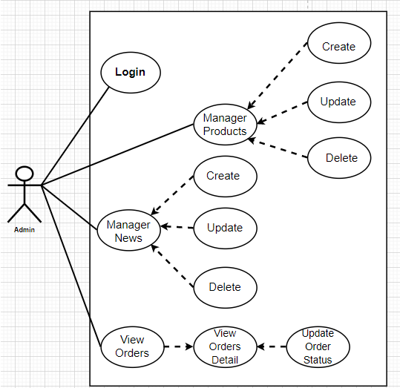ADMIN

|  |  |  |
| --- | --- | --- |
| **Author** |  | |
| **Use case name** | Login | |
| **Actor** | Admin | |
| **Description** | When admin wants to manage products, news, views orders and orders detail | |
| **Requirements** | Admin provides username and password | |
| **Pre-conditions** | Admin must be exist on database | |
| **Post-conditions** | Success: Admin is logged in to website admin | |
| Fail: refill information | |
| **Basic flow** | **Actor’s actions** | **System’s responses:** |
| 1. Actor clicks on ‘Login’ button.  3. Actor inputs Email and Password,  then click the ‘Login’ button. | 2. System redirects to Login Page with the following controls:   * 'Email' text field * 'Password' text field * 'Login' button  1. System validates the information.   System redirects to Admin website |
| **Exceptions** | **Actor’s actions:** | **System’s responses:** |
| 1. Actor inputs invalid email and password | System redirects to Login page with the following controls:   * ‘Email’ text field * ‘Password’ text field * ‘Login’ button. |

## PRODUCTS

Create new Product

|  |  |  |
| --- | --- | --- |
| **Author** |  | |
| **Use case name** | Create new product | |
| **Actor** | Admin | |
| **Description** | When admin wants to create a new product | |
| **Requirements** | Actor provides product’s information | |
| **Pre-conditions** | Actor is logged in admin | |
| **Post-conditions** | Success: new product is added into the database | |
| Fail: refill information | |
|  | **Actor’s actions:** | **System’s responses:** |
|  |  | 2. System redirects to ‘Product’ page  and display a list of existing product. |
|  | 1. Actor chooses Product Tab on menu. |  |
|  | 3. Actor clicks ‘Add New Product’  button. | 4. System displays a form with the  following fields: |
|  |  | - id |
|  | 5. Actor inputs information to create  new product | - category_id |
| **Basic flow** |  | - sale_id |
|  |  | - name |
|  |  | - name_slug |
|  |  | - description |
|  |  | * view_count * quantity * active * detail * image  1. System validates inputs. 2. System adds product into database.   System displays confirmation message or error message. |

|  |  |  |
| --- | --- | --- |
|  |  | * view_count * quantity * active * detail * image  1. System validates inputs. 2. System adds product into database. 3. System displays confirmation message or error message. |

Update Product

|  |  |  |
| --- | --- | --- |
| **Author** |  | |
| **Use case name** | Update product’s detail | |
| **Actor** | Admin | |
| **Description** | When admin wants to update product | |
| **Requirements** | Admin provides product’s information | |
| **Pre-conditions** | Actor is logged in admin | |
| **Post-conditions** | Success: product is updated in the database | |
| Fail: refill information | |
|  | **Actor’s actions:** | **System’s responses:** |
| 1. Actor chooses Product Tab on menu. | 2. System redirects to ‘Product Details’  page and display a list of existing |

|  |  |  |
| --- | --- | --- |
| **Basic flow** | 3. Actor clicks on ‘View Details’ on a  product.  5. Actor chooses the criteria they want to update and input information. | product.  4. System displays a form with the following fields.   * category_id * sale_id * name * name_slug * description * price * view_count * quantity * active * detail * image  1. System validates inputs. 2. System update product into database. 3. System displays confirmation message or error message. 4. System redirects to product’s detail   page. |

Delete Product

|  |  |
| --- | --- |
| **Author** |  |
| **Use case name** | Delete Product |

|  |  |  |
| --- | --- | --- |
| **Actor** | Admin | |
| **Description** | When admin wants to delete product from the database | |
| **Requirements** | Admin provides product’s information | |
| **Pre-conditions** | Actor is logged in admin | |
| **Post-conditions** | Success: product is delete in the database | |
| Fail: product is not delete from the database | |
|  | **Actor’s actions:** | **System’s responses:** |
|  | 1. Actor chooses Product Tab on menu.  3. Actor clicks ‘Delete’ button. | 2. System redirects to ‘Product List’ page and display a list of existing product. |
|  |  | 4. System delete product in the database |
| **Basic flow** |  | 5. System displays confirmation or error. |

MANAGE

CREATE NEW MANAGE

|  |  |  |  |  |
| --- | --- | --- | --- | --- |
| **Author** | |  | | |
| **Use case name** | | Create News | | |
| **Actor** | | Admin | | |
| **Description** | | When admin wants to create a News | | |
| **Requirements** | | **Admin provides New content** | | |
| **Pre-conditions** | | **Actor is logged in admin** | | |
| **Post-conditions** | | **Success: News content is added into the website** | | |
| **Fail: admin can’t create News** | | |
|  | | **Actor’s actions:** | | **System’s responses:** |
|  | | 1. Actor chooses News Tab on menu. | | 2. System redirects to ‘News’ page and  display a list of News. |
|  | | 3. Actor clicks ‘Add New Content’  button. | | 4. System displays a form with the following fields: |
|  | | 5. Actor inputs information to create  news | | - id |
|  | |  | | - name |
| **Basic flow** | |  | | - content |
|  | |  | | - image |
|  | |  | | 6. System validates inputs. |
|  | |  | | 7. System adds News into website. |
|  | |  | | 8. System displays confirmation message or error message. |

UPDATE MANAGE

|  |  |  |  |  |
| --- | --- | --- | --- | --- |
| **Author** | |  | | |
| **Use case name** | | Update News on the website | | |
| **Actor** | | Admin | | |
| **Description** | | **When admin wants to update news information** | | |
| **Requirements** | | **Admin provides News Content** | | |
| **Pre-conditions** | | **Actor is logged in admin** | | |
| **Post-conditions** | | **Success: News is updated in the website** | | |
| **Fail: admin can’t update News** | | |
|  | | **Actor’s actions:** | | **System’s responses:** |
|  | | 1. Actor chooses News Tab on menu. | | 2. System redirects to ‘News’ page and  display a list of News. |
|  | | 3. Actor clicks ‘View Details’ button. | |  |
|  | | 5. Actor chooses the criteria they want to update and input information. | | 4. System displays a form with the  following fields. |
|  | |  | | - name |
|  | |  | | - content |
|  | |  | | - image |
|  | |  | | 6. System validates inputs. |
| **Basic flow** | |  | | 7. System update News Content to website. |
|  | |  | | 8. System displays confirmation message or error message. |
|  | |  | | 9. System redirects to Home. |

DELETE MANAGE

|  |  |  |  |  |
| --- | --- | --- | --- | --- |
| **Author** | |  | | |
| **Use case name** | | Delete News | | |
| **Actor** | | **Admin** | | |
| **Description** | | **When admin wants to delete News from the website** | | |
| **Requirements** | | **Admin provides News Content** | | |
| **Pre-conditions** | | **Actor is logged in admin** | | |
| **Post-conditions** | | **Success: product is delete in the website** | | |
| **Fail: product is not delete from the website** | | |
| **Basic flow** | | **Actor’s actions:** | | **System’s responses:** |
| 1. Actor chooses News Tab on menu.  3. Actor clicks ‘Delete’ button. | | 2. System redirects to ‘News List’ page  and display a list of News.   1. System delete News in the website 2. System displays confirmation or error. |

ORDER

VIEW ORDER

|  |  |  |  |  |
| --- | --- | --- | --- | --- |
| **Author** | |  | | |
| **Use case name** | | View Order | | |
| **Actor** | | Admin | | |
| **Description** | | When admin wants to know the order of the product | | |
| **Requirements** | | Admin has at least 1 order on website. | | |
| **Pre-conditions** | | **Actor is logged in admin** | | |
| **Post-conditions** | | **Success: product is shown in the website** | | |
| **Fail: Page View Order cannot see from the website** | | |
| **Basic flow** | | **Actor’s actions:** | | **System’s responses:** |
| 1. Actor chooses View Order on menu.  3. Actor clicks ‘View’ button. | | 2. System redirects to ‘Order List’ page  and display a list of Order.   1. System show Order in the website. 2. System displays confirmation or error. |

VIEW ORDER DETAIL

|  |  |  |
| --- | --- | --- |
| **Author** |  | |
| **Use case name** | View Order Detail | |
| **Actor** | Admin | |
| **Description** | When admin wants to see View Order Detail from the website | |
| **Requirements** | Admin has at least 1 order on website. | |
| **Pre-conditions** | Actor is logged in admin | |
| **Post-conditions** | Success: Admin can view Order Detail on the website | |
| Fail: Admin cant’ view the Order Detail on the website | |
| **Basic flow** | **Actor’s actions:** | **System’s responses:** |
| **1. Actor chooses View Order on menu.**  **3. Actor clicks ‘Detail’ button.** | **2. System redirects to ‘Order List’ page**  **and display a list of Order.**   1. **System show Order Details in the website** 2. **System displays confirmation or error.** |

UPDATE ORDER STATUS

|  |  |  |
| --- | --- | --- |
| **Author** |  | |
| **Use case name** | Update Order Status | |
| **Actor** | Admin | |
| **Description** | When admin wants to update Order Status from the website | |
| **Requirements** | Admin has at least 1 order on website. | |
| **Pre-conditions** | Actor is logged in admin | |
| **Post-conditions** | Success: Admin can update Order Status on the website | |
| Fail: Admin can’t update Order Status on the website | |
| **Basic flow** | **Actor’s actions:** | **System’s responses:** |
| 1. Actor chooses View Order Tab on menu.  3. Actor clicks ‘Delete’ button. | 2. System redirects to ‘Order List’ page  and display a list of Order.   1. System update Order Status in the website 2. System displays confirmation or |

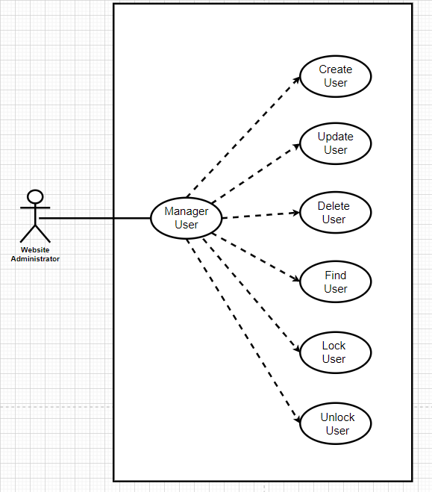WEBSITE ADMINISTRATOR

CREATE CUSTOMER

|  |  |  |
| --- | --- | --- |
| **Author** |  | |
| **Use case name** | Create Customer | |
| **Actor** | Admin | |
| **Description** | When admin wants to create customer | |
| **Requirements** | Actor provides customer information | |
| **Pre-conditions** | Actor is logged in admin | |
| **Post-conditions** | Success: new Customer is added into the database | |
| Fail: refill information | |
| **Basic flow** | **Actor’s action** | **System’s responses:** |
| 1. Actor chooses Customer Tab on menu.  3. Actor clicks ‘Add New Customer’  button.  5. Actor inputs information to create Customer. | 2. System redirects to ‘Customer’ page  and display a list of existing Customers.  4. System displays a form with the following fields:   * id * fullname * username * password * address * phone * email * birthday |

|  |  |  |
| --- | --- | --- |
|  |  | * gender * active  1. System validates inputs. 2. System adds new customer into database. 3. System displays confirmation message or error message. |

UPDATE CUSTOMER

|  |  |  |
| --- | --- | --- |
| **Author** |  | |
| **Use Case Name** | Update Customer | |
| **Actors** | Admin | |
| **Description** | When admin wants to Update customer | |
| **Requirements** | Actor provides customer information | |
| **Pre-conditions** | Actor is logged in admin | |
| **Post-condition** | Success: Customer is update into the database | |
| Fail: refill information | |
| **Basic flow** | **Actor’s action** | **System’s responses:** |
| 1. Actor chooses Customer Tab on menu.  3. Actor clicks on ‘View Details’ on a  Customer  5. Actor chooses the criteria they want to update and input information. | 2. System redirects to ‘Customer’ page  and display a list of existing Customers.  4. System displays a form with the following fields:   * fullname * username |

|  |  |  |
| --- | --- | --- |
|  |  | * password * address * phone * email * birthday * gender * active  1. System validates inputs. 2. System update customer into database. 3. System displays confirmation message or error message. 4. System redirects to customer’s detail   page. |

DELETE CUSTOMER

|  |  |  |  |
| --- | --- | --- | --- |
| **Author** | |  | |
| **Use Case Name** | | Delete Customer | |
| **Actors** | | Admin | |
| **Description** | | When admin wants to delete customer | |
| **Requirements** | | Actor provides customer information | |
| **Pre-conditions** | | Actor is logged in admin | |
| **Post-condition** | | Success: Customer is delete from the database | |
|  | | **Fail: Customer is not deleted from the database** | |
| **Basic flow** | **Actor’s action** | | **System’s responses:** |
| 1. Actor chooses Customer Tab on menu.  3. Actor clicks ‘Delete’ button. | | 2. System redirects to ‘Customer’ page  and display a list of existing Customers.   1. System delete customer in the database. 2. System displays confirmation message or error message. |

FIND CUSTOMER

|  |  |  |  |  |
| --- | --- | --- | --- | --- |
| **Author** | |  | | |
| **Use Case Name** | | Find Customer | | |
| **Actors** | | Admin | | |
| **Description** | | When admin wants to find customer by ID | | |
| **Requirements** | | Actor provides Customer’s id | | |
| **Pre-conditions** | | Actor is logged in admin | | |
| **Post-condition** | | Success: Show customer that matches ID | | |
| Fail: No customer is shown | | |
| **Basic flow** | | **Actor’s action** | | **System’s responses:** |
| 1 Actor inputs ID.  3. Actor clicks customer’s title in list or  view, which matches the ID. | | 2. System show list of customer that match the ID. |
| **Author** |  | | | |
| **Use Case Name** | Lock Customer | | | |
| **Actors** | Admin | | | |
| **Description** | When admin wants to lock a customer | | | |
| **Requirements** | Actor provides Customer’s information | | | |
| **Pre-conditions** | Actor is logged in admin | | | |
| **Post-condition** | Success: set customer’s status into “Lock” and updated in database | | | |
| Fail: No changes are made | | | |
| **Basic flow** | **Actor’s action** | | **System’s responses:** | |
| 1. Actor chooses Customer row on  User list and click “disable” button | | 1. System updates Customer’s status   into database.   1. System displays confirmation message or error message. | |

## DATA FLOW DIAGRAM (DFD)

Level 0: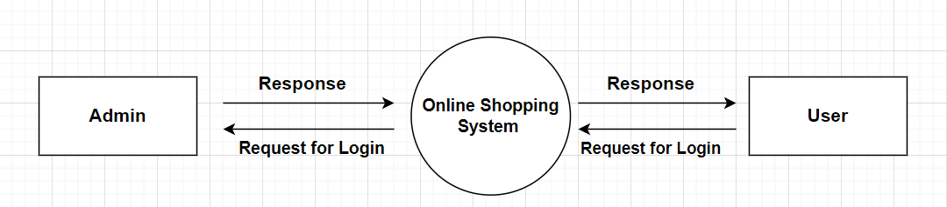

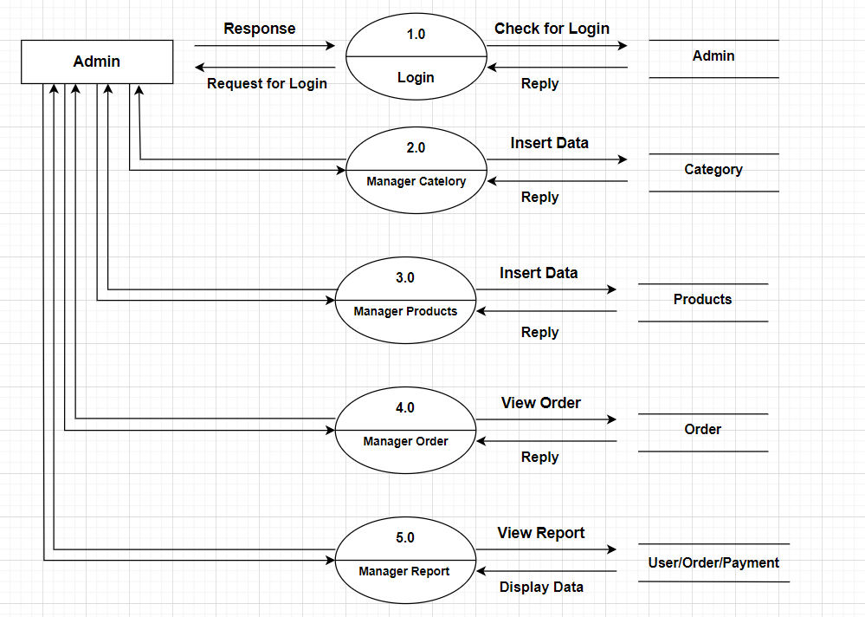Adminside Level 1:

Adminside Level 2:

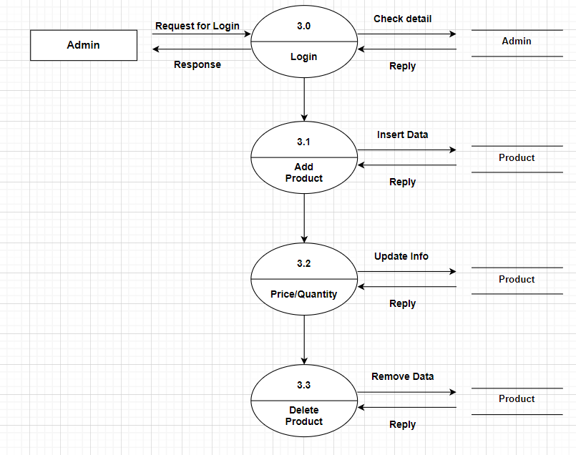

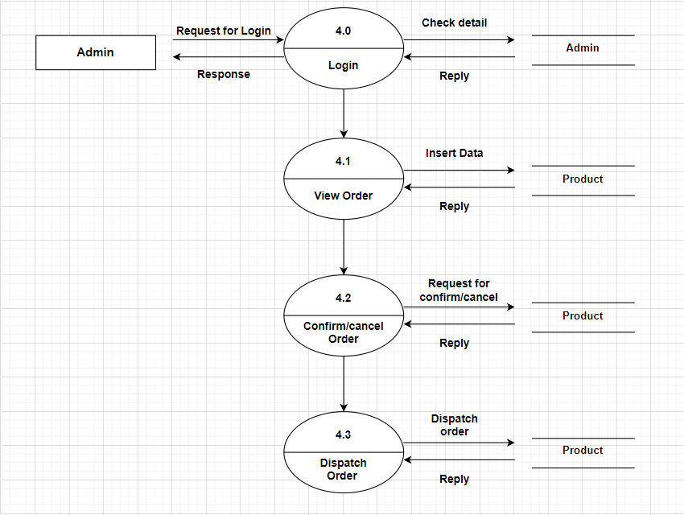Adminside Level 3:

Adminside Level 4:

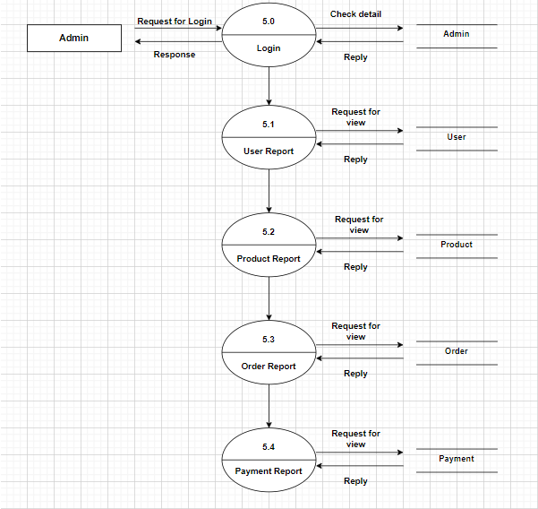

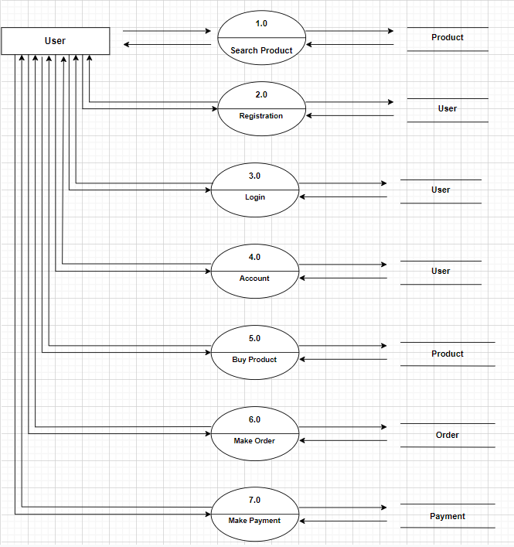Userside Level 1:

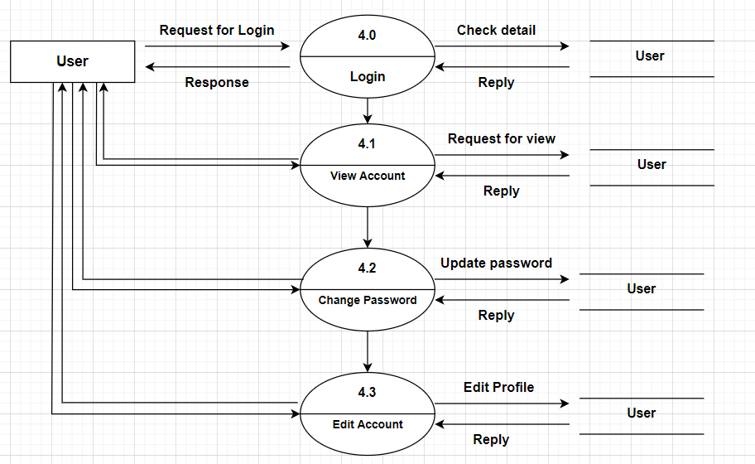Userside Level 2:

Userside Level 3: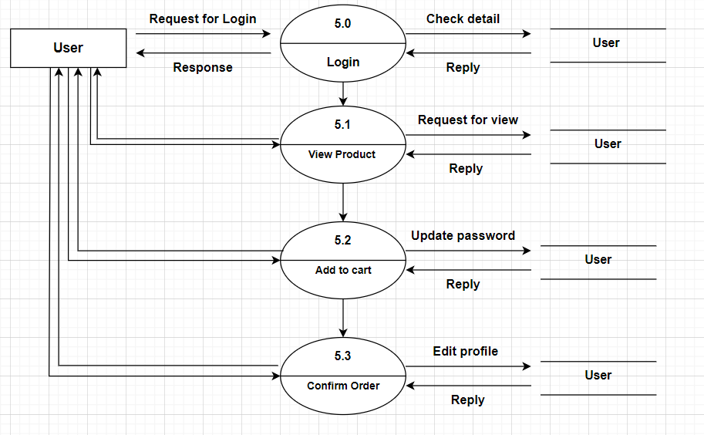

## ENTITY PROPERTIES

CUSTOMER

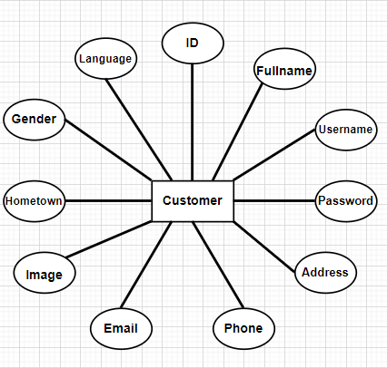

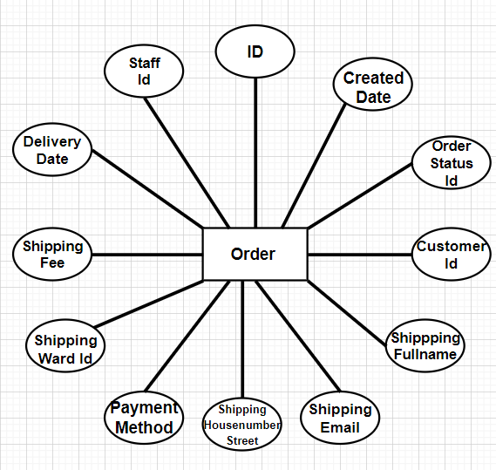ORDER

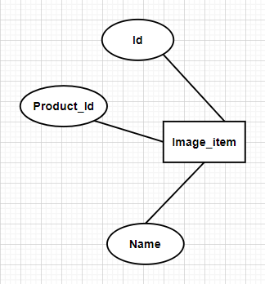IMAGE_ITEM

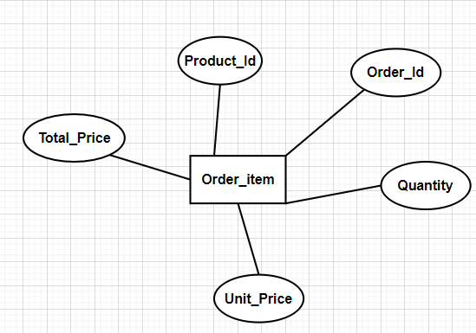ORDER_ITEM

CATEGORY

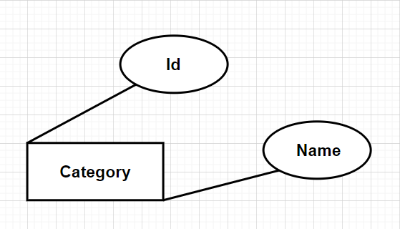

BRAND

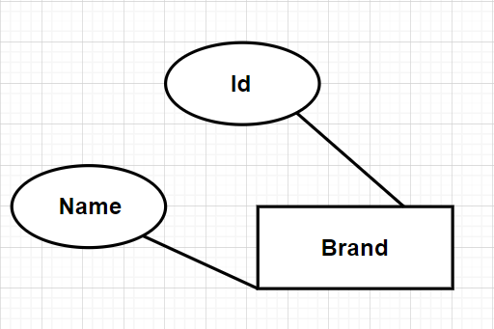

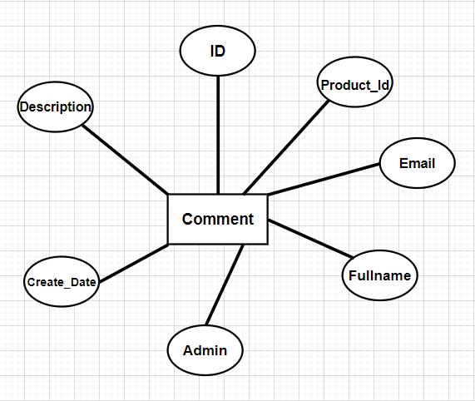COMMENT

USER

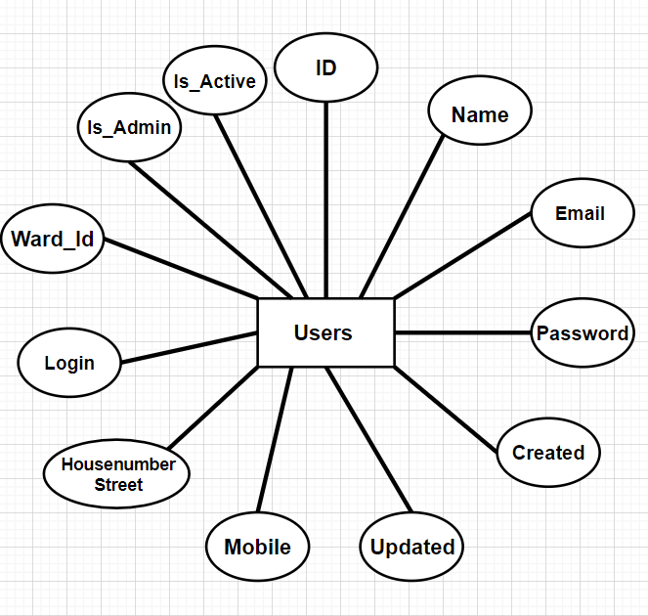

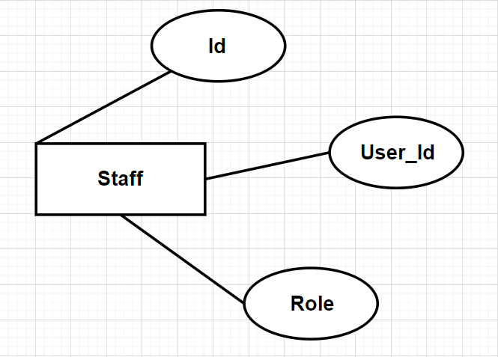STAFF

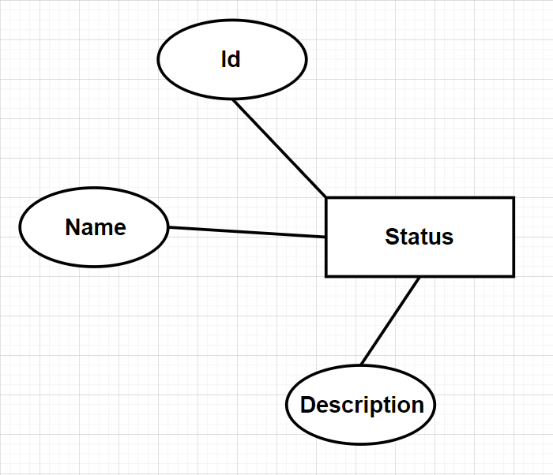STATUS

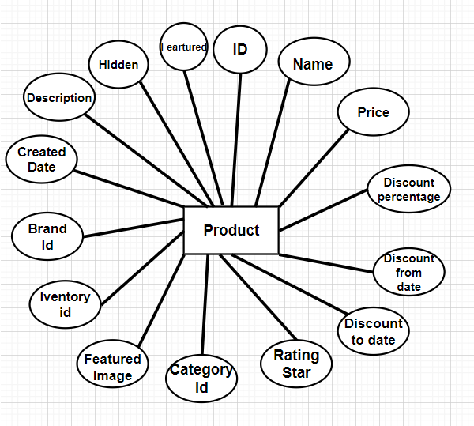PRODUCT

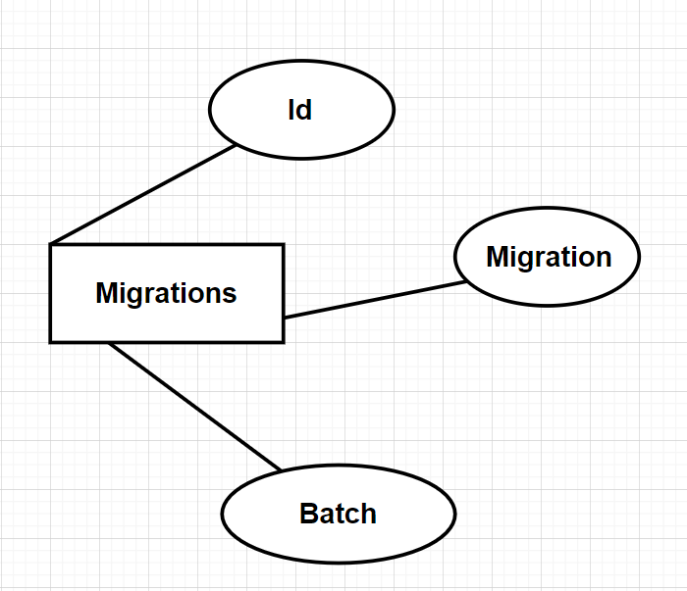MIGRATIONS

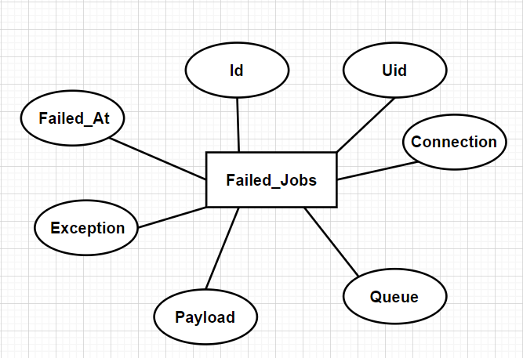FAILED_JOBS

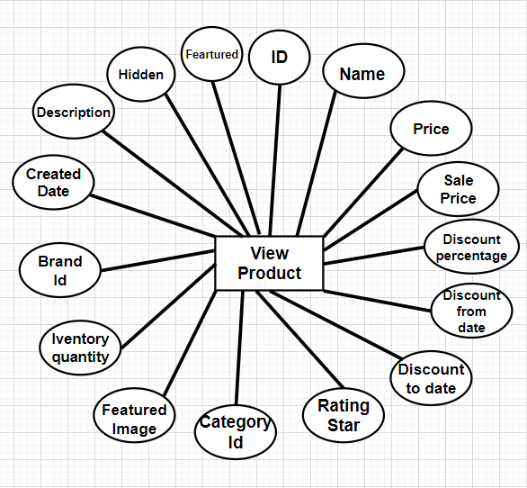VIEW_PRODUCT

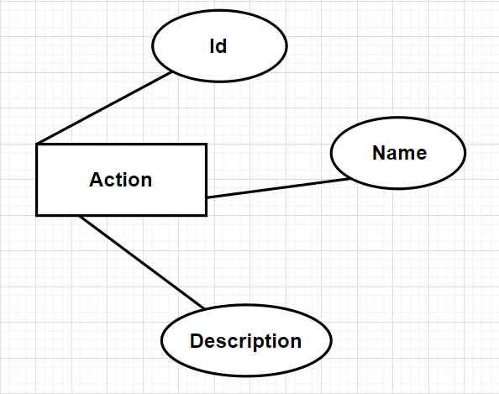ACTION

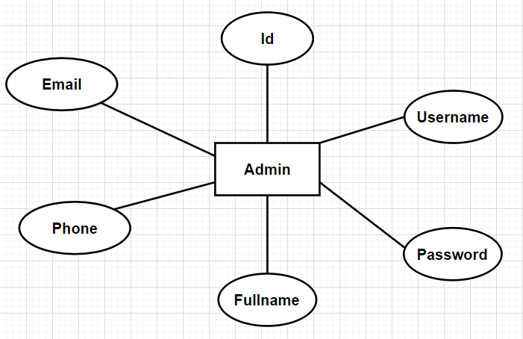ADMIN

## ENTITY RELATIONSHIP DIAGRAM (ERD)

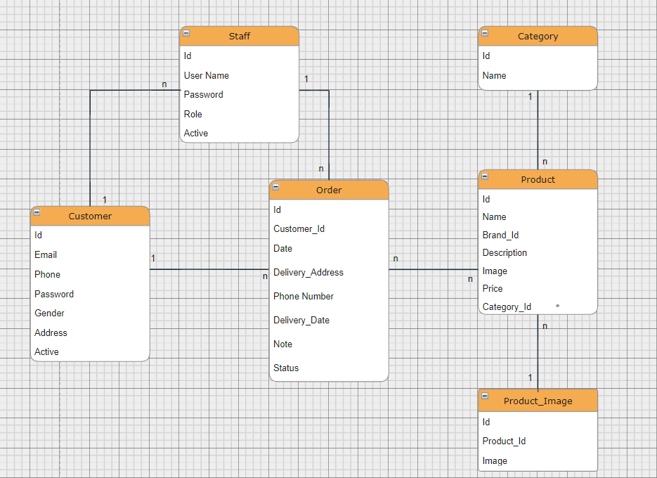LOGICALEDR

## TABLE DESIGN

TABLESTRUCTURE FOR TABLE BRAND

|  |  |  |  |
| --- | --- | --- | --- |
| **TABLE BRANDS** | | | |
| **Column** | **Type** | **Null** | **Default** |
| **Id** | Int(100) | No |  |
| **sname** | varchar(200) | No |  |
| **lname** | varchar(200) | No |  |
| **tomtatgt** | varchar(1000) | No |  |
| **logo** | varchar(200) | No |  |
| **web** | varchar(200) | No |  |

## TABLE STRUCTURE FOR TABLE CATEGORY

|  |  |  |  |
| --- | --- | --- | --- |
| **TABLE CATEGORY** | | | |
| **Column** | **Type** | **Null** | **Default** |
| **Id** | Int(20) | No |  |
| **name** | varchar(200) | No |  |

## TABLE STRUCTURE FOR TABLE COMMENT

|  |  |  |  |
| --- | --- | --- | --- |
| **TABLE COMMENT** | | | |
| **Column** | **Type** | **Null** | **Default** |
| **Id** | Int(100) | No |  |
| **Product_id** | Int(100) | No |  |
| **Custmer_id** | Int(100) | No |  |
| **contact** | varchar(200) | No |  |
| **date** | datetime | No |  |
| **rate** | varchar(200) | No |  |

## TABLE STRUCTURE FOR TABLE PRODUCT

|  |  |  |  |
| --- | --- | --- | --- |
| **TABLE PRODUCT** | | | |
| **Column** | **Type** | **Null** | **Default** |
| **Id** | Int(100) | No |  |
| **name** | varchar(200) | No |  |
| **Brand_id** | Int(100) | No |  |
| **description** | Text | No |  |
| **image** | varchar(200) | No |  |
| **price** | varchar(200) | No |  |
| **Category_id** | Int(100) | No |  |

## TABLE STRUCTURE FOR TABLE PRODUCT_IMAGE

|  |  |  |  |
| --- | --- | --- | --- |
| **TABLE PRODUCT_IMAGE** | | | |
| **Column** | **Type** | **Null** | **Default** |
| **Id** | Int(100) | No |  |
| **Product_id** | Int(100) | No |  |
| **lname** | varchar(200) | No |  |

## TABLE STRUCTURE FOR TABLE CUSTOMER

|  |  |  |  |
| --- | --- | --- | --- |
| **TABLE CUSTOMER** | | | |
| **Column** | **Type** | **Null** | **Default** |
| **Id** | Int(100) | No |  |
| **email** | varchar(200) | No |  |
| **tel** | varchar(200) | No |  |
| **password** | varchar(200) | No |  |
| **gender** | enum | No |  |
| **address** | varchar(200) | No |  |
| **active** | enum | No |  |

## TABLE STRUCTURE FOR TABLE STAFF

|  |  |  |  |
| --- | --- | --- | --- |
| **TABLE STAFF** | | | |
| **Column** | **Type** | **Null** | **Default** |
| **Id** | Int(100) | No |  |
| **Username** | varchar(200) | No |  |
| **password** | varchar(200) | No |  |
| **role** | enum | No |  |
| **active** | enum | No |  |

## TABLE STRUCTURE FOR TABLE WISHLIST

|  |  |  |  |
| --- | --- | --- | --- |
| **TABLE WISHLIST** | | | |
| **Column** | **Type** | **Null** | **Default** |
| **Id** | Int(100) | No |  |
| **Product_id** | Int(100) | No |  |
| **Custmer_id** | Int(100) | No |  |

## TABLE STRUCTURE FOR TABLE ORDER

|  |  |  |  |
| --- | --- | --- | --- |
| **TABLE ORDER** | | | |
| **Column** | **Type** | **Null** | **Default** |
| **Id** | Int(100) | No |  |
| **Custmer_id** | Int(100) | No |  |
| **date** | datetime | No |  |
| **Delivery_address** | varchar(200) | No |  |
| **telephone** | varchar(200) | No |  |
| **Delivery_date** | datetime | No |  |
| **note** | varchar(200) | No | NULL |
| **status** | varchar(200) | No | NULL |
| **pin** | varchar(200) | No |  |
| **Dayment_term** | varchar(200) | No |  |
| **Total_amt** | varchar(200) | No |  |

## TABLE STRUCTURE FOR TABLE ORDER_DETAIL

|  |  |  |  |
| --- | --- | --- | --- |
| **TABLE ORDER_DETAIL** | | | |
| **Column** | **Type** | **Null** | **Default** |
| **Id** | Int(100) | No |  |
| **Order_id** | Int(100) | No |  |
| **Product_id** | Int(100) | No |  |
| **qty** | varchar(200) | No |  |
| **price** | varchar(200) | No |  |
| **amout** | varchar(200) | No |  |

## TASK SHEET REVIEW 2

|  |  |  |  |  |  |  |  |
| --- | --- | --- | --- | --- | --- | --- | --- |
| **Project: Liquor Stores** | | **Project Name** | **Activity Plan Prepared By** | **Date of Preparation of Activity Plan:** | | | |
| **Sr./No.** | **Task** | Actual Start Date | Actual Days | Team member name | Status |
| **1** | **Use Case** | **Game Gear** | Trọng | 27-Jun-22 | 3 | Trọng | Completed |
| **2** | **Data Flow Diagram (DFD)** | 29-Jun-22 | 3 | Thuận | Completed |
| **3** | **Entity Relationship Diagram (ERD)** | 28-Jun-22 | 3 | Trọng | Completed |
| **4** | **Entity Properties** | 28-Jun-22 | 3 | Trọng | Completed |
| **5** | **Table Design** | 27-Jun-22 | 3 | Thuận | Completed |
| Date: 30 June 2022 | | | | | | | |

|  |  |
| --- | --- |
| **Signature of Instructor:**  Ms. Le Mong Thuy | **Signature of Team Leader:**  Nguyễn Trần Trọng |

# **REVIEW 3**

## SITE MAP

1. HOME SITE MAP

**Contact Us**

Home

Menu

**About Us**

**Avatar**

**Computer Mouse**

**Keyboards**

**Gamepads**

**Game Headphone**

**Checkout**

**Catalog**

**Category**

**Cart**

**Our Products**

**Search**

2. LOGIN SITE MAP

**Cart**

Register

**Checkout**

Member

**Order History**

Login

Admin

**View Product**

**Add Product**

**Edit Product**

**Delete Product**

## GAME GEAR WIREFRAME

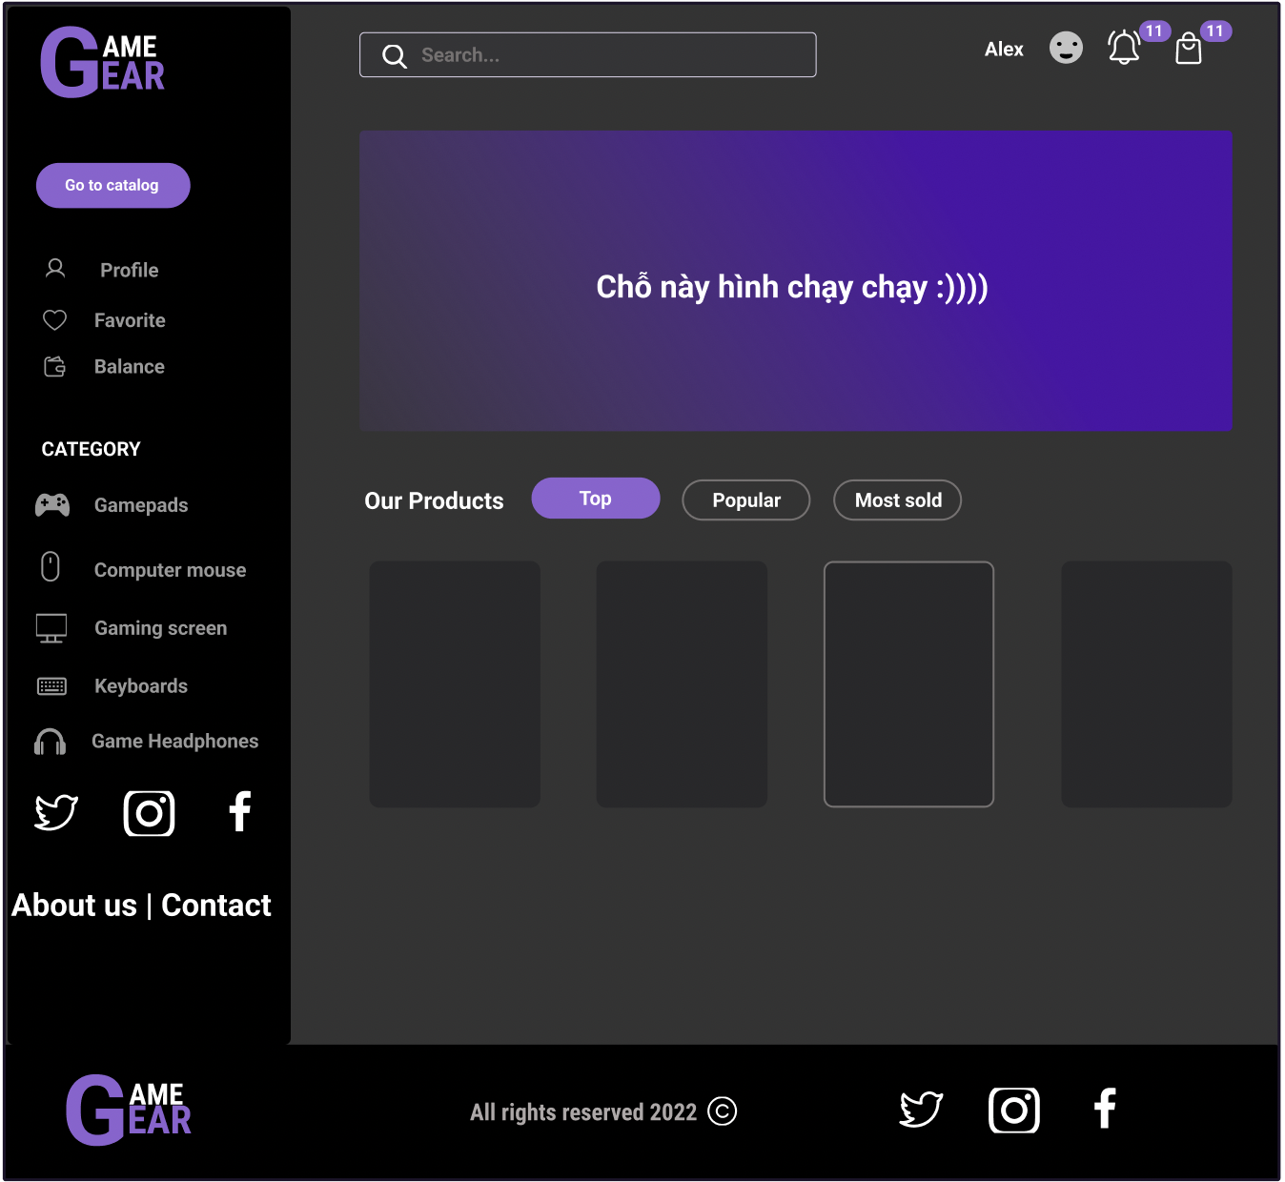HOMEPAGE

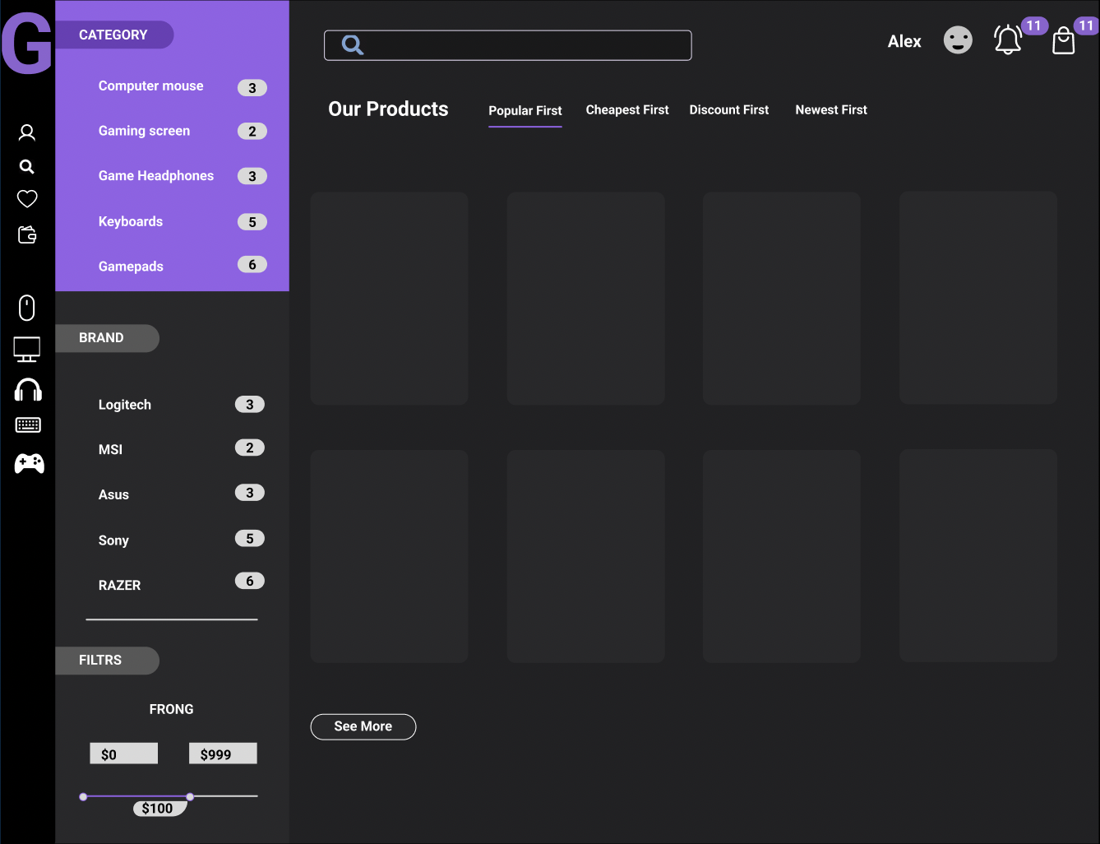CATEGORY PRODUCT

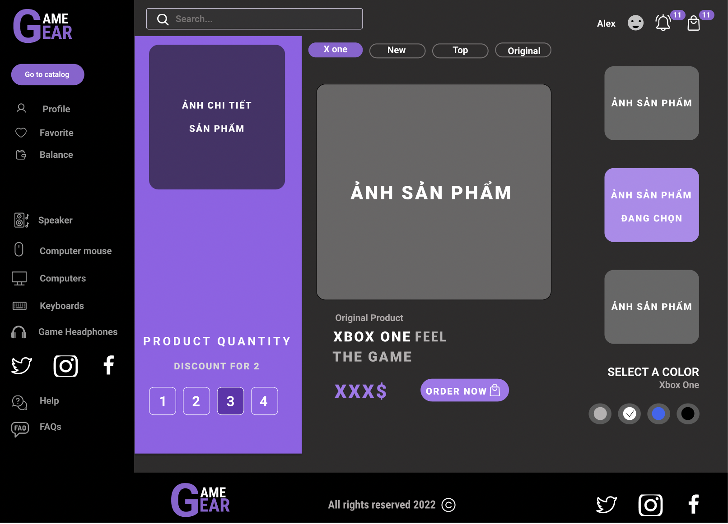PRODUCT DETAILS

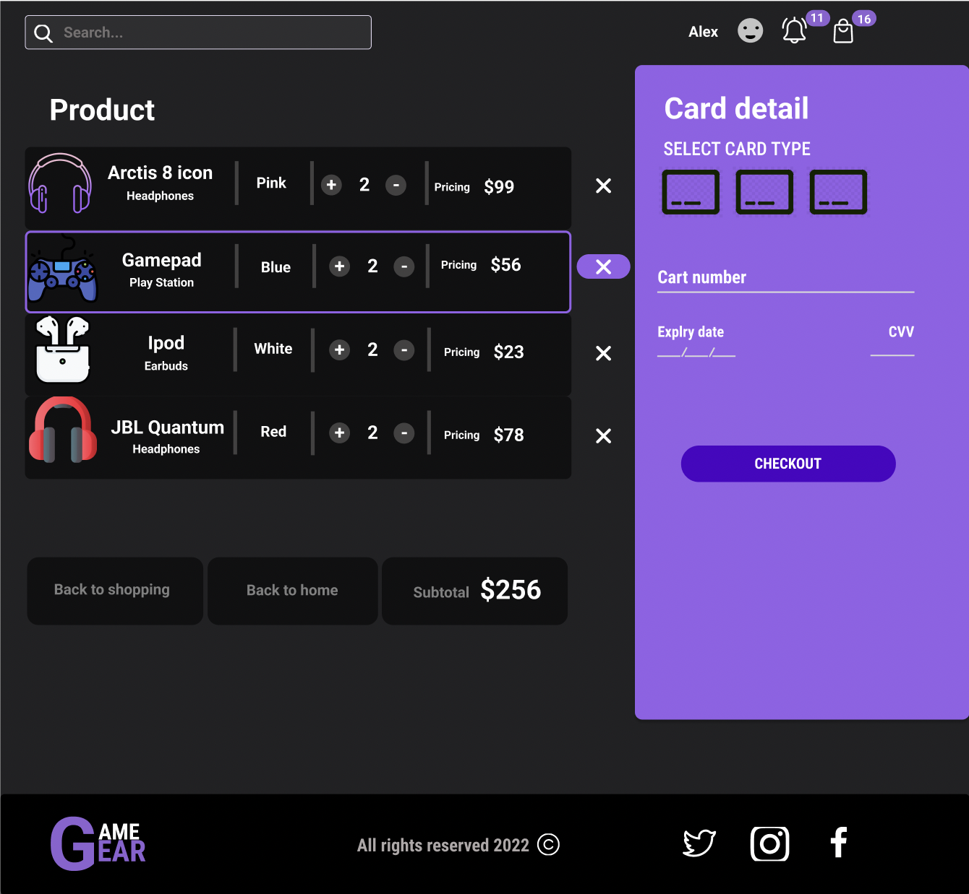CHECKOUT

## CONTACT US

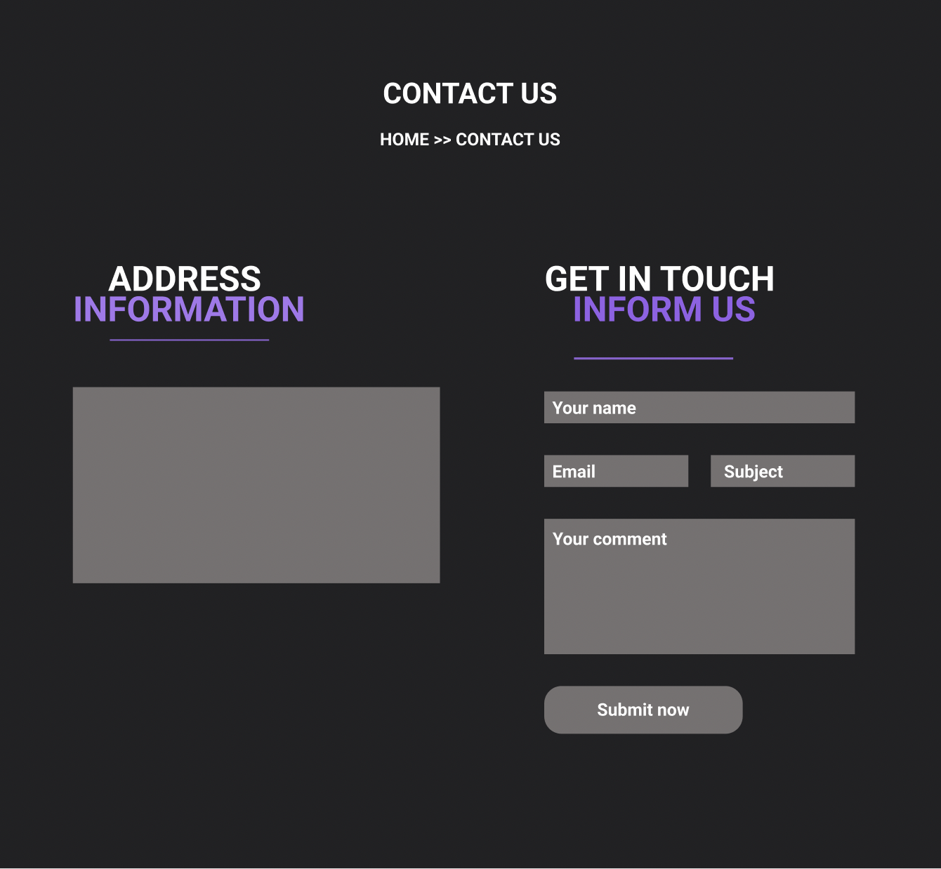

## SIGN UP

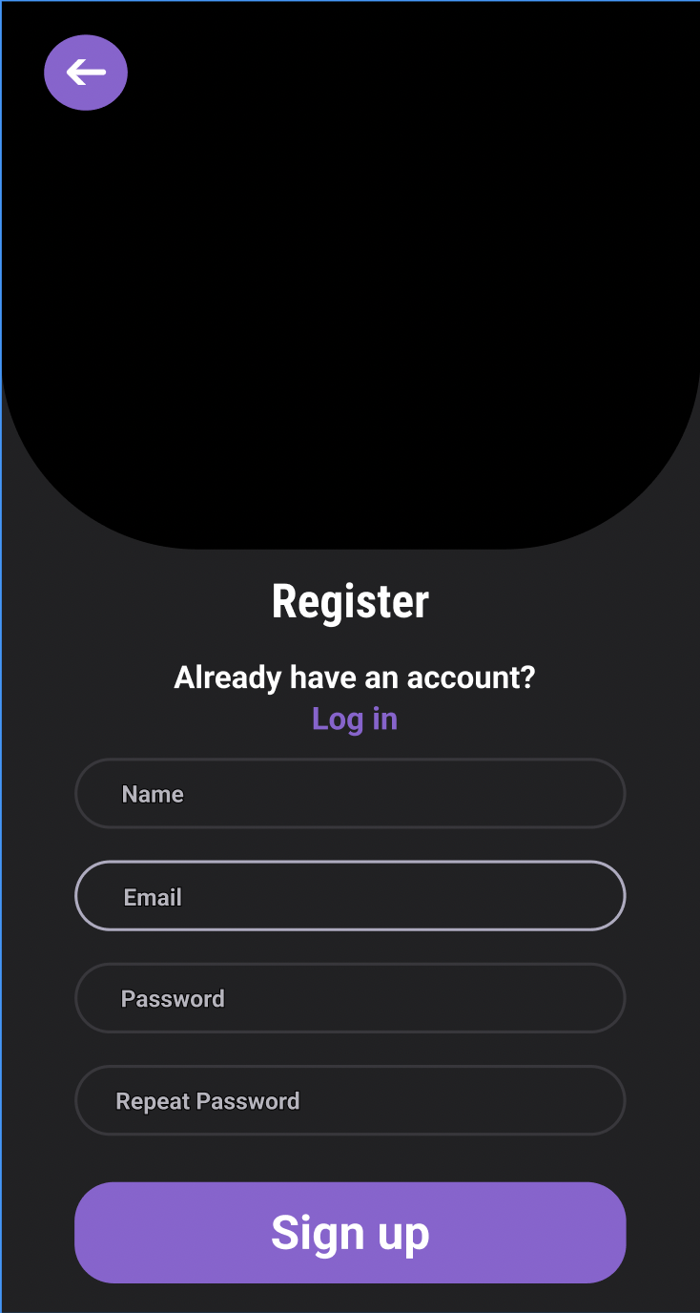

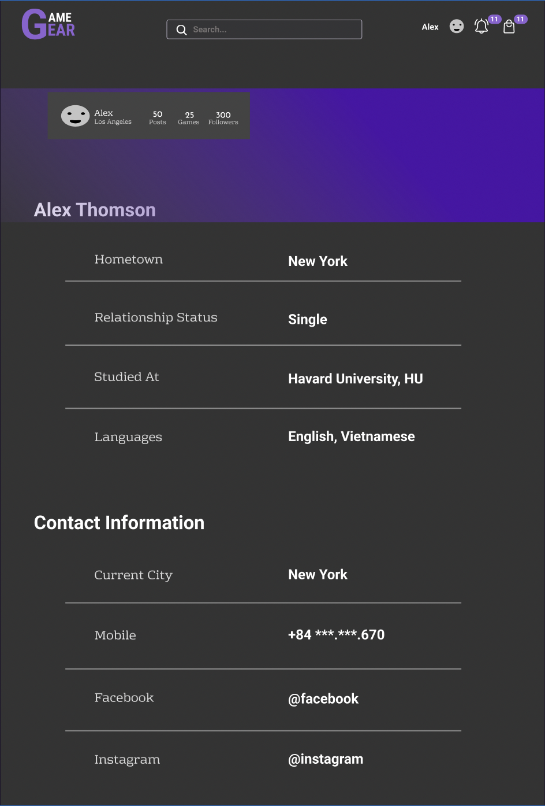PROFILE

## LOGIN

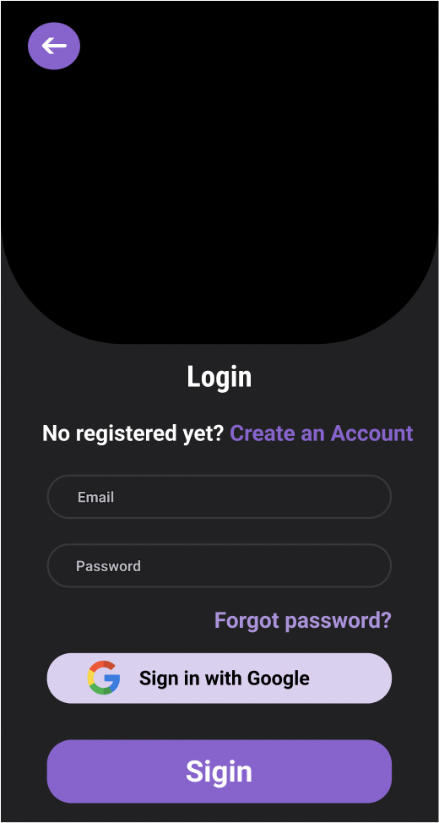

ABOUT US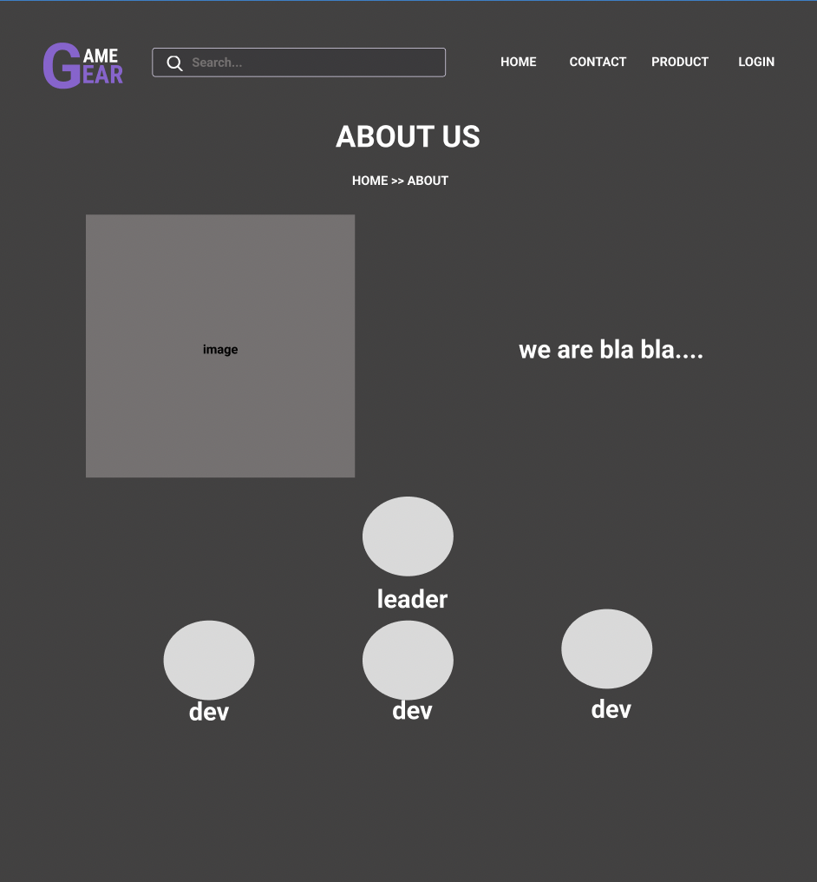

## 3. GAME GEAR SCREENSHOT

## HOME PAGE

Search product

Logo website

Menu

Notification

Name USER

Cart

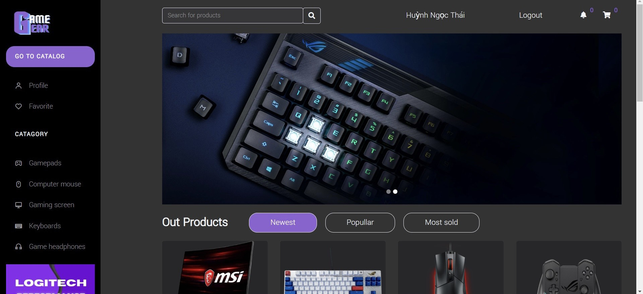

Product Image

Banner

## CATEGORY PAGE

Product category menu

Cheapest Product

Popullar First Product

Newest First Product

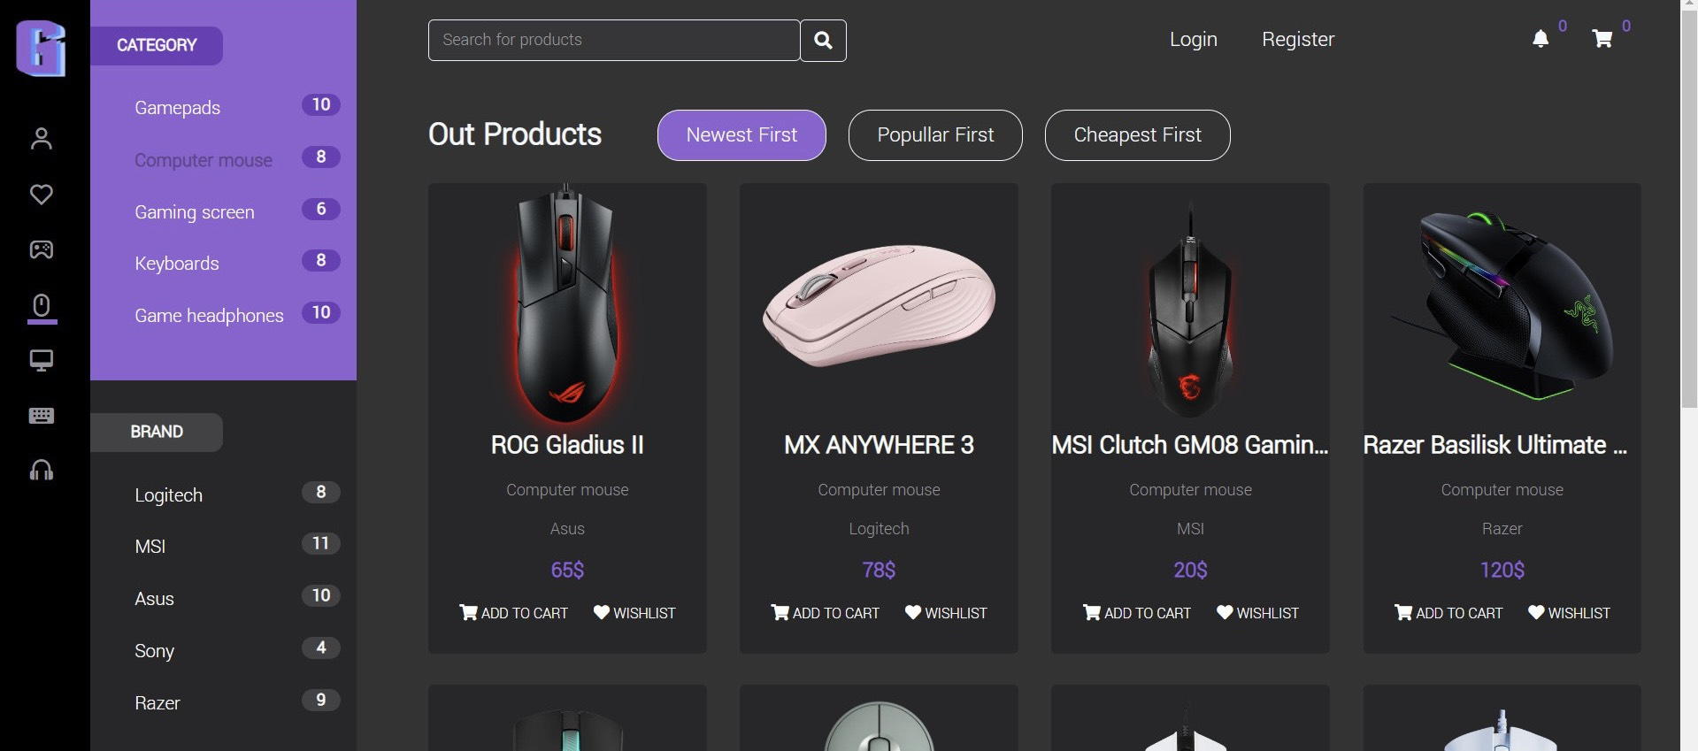

Types Brand

## HISTORY ORDER PAGE

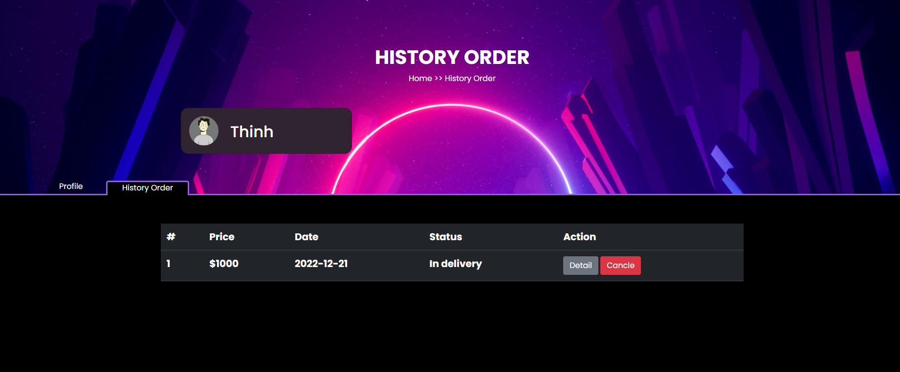

Date Order

Status product

Detail Order

Price Product

ID order

Cancle product

## DETAIL HISTORY ORDER

Estimated delivery

Date Order

Clone detail

Total Price

Payments

Address delivery

Price Product

Status product

ID order

## USER PROFILE

# 

Name USER

Avatar USER

Name USER

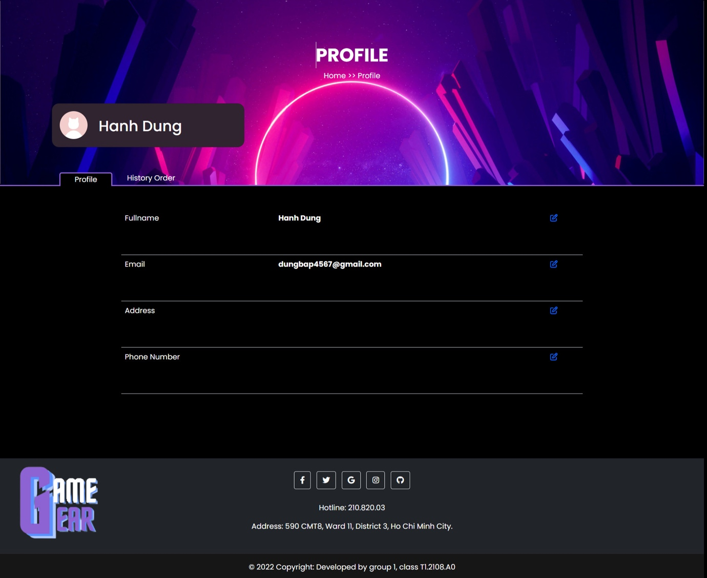

Edit Profile

Phone Number

Address USER

Email USER

Product Type

Product Image

Name Brand

PR Brand

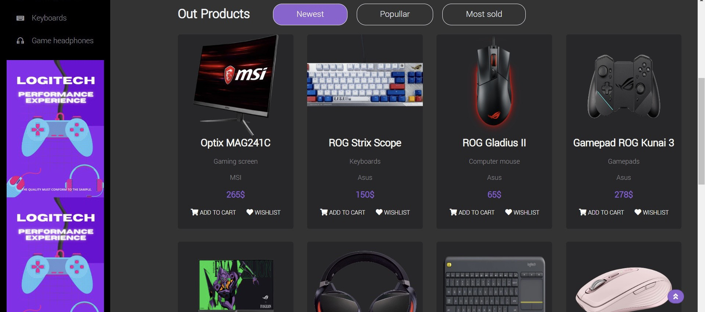

Price Product

Add product to cart

Add to favorites

Name Brand

Total price of this product

Product Quantity

Delete Product

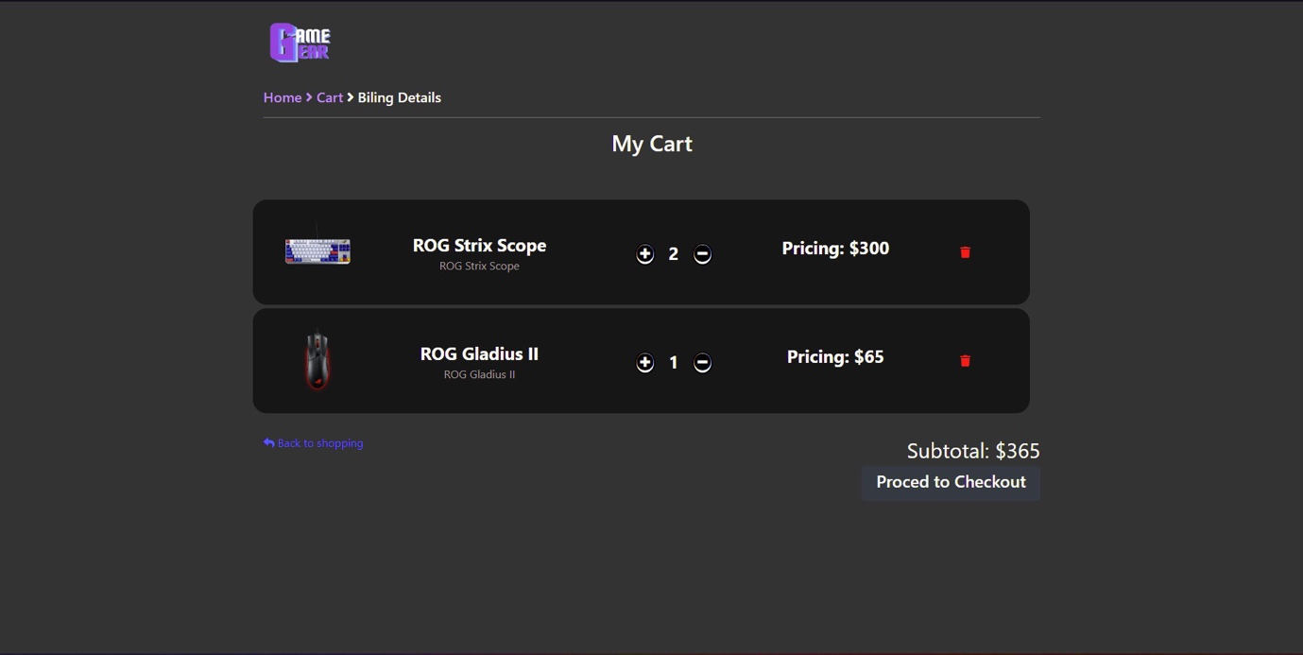

Total value of all products

Reduce the number of

Increasing the number

Back to shopping

# 

Content About

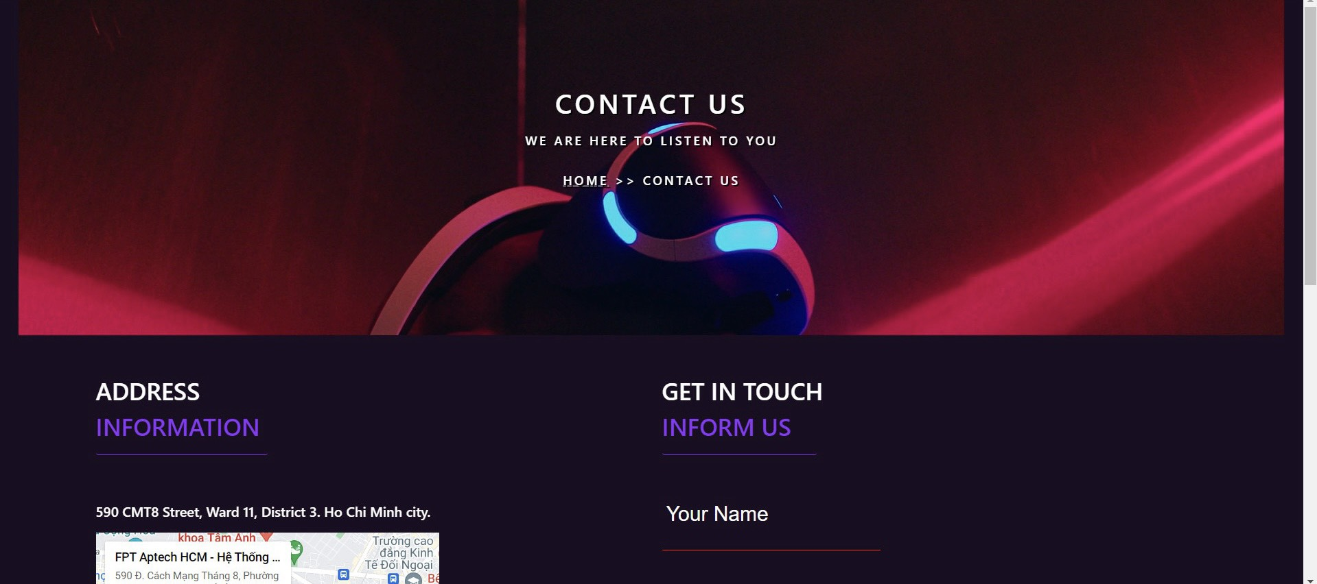

Content Contact

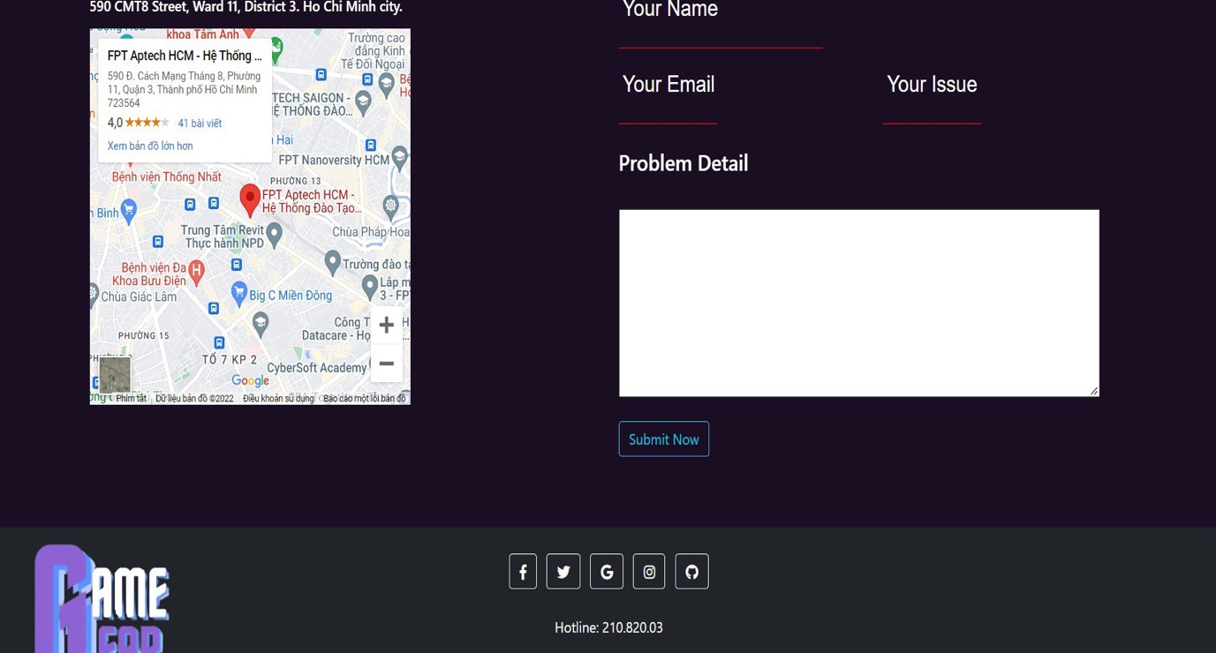

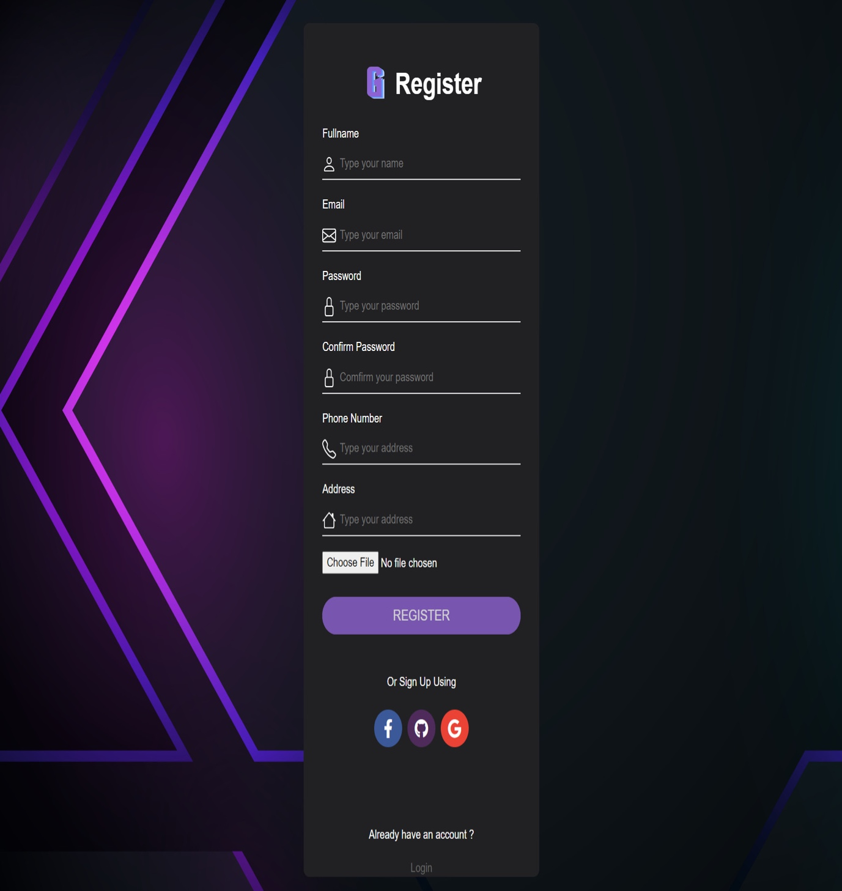

Enter Name

Enter Email

Enter Password

Confirm Password

Enter Phone Number

Enter Address

Upload picture

Submit REGISTER

Register with Facebook – GitHub - Google

Name user

Star rating

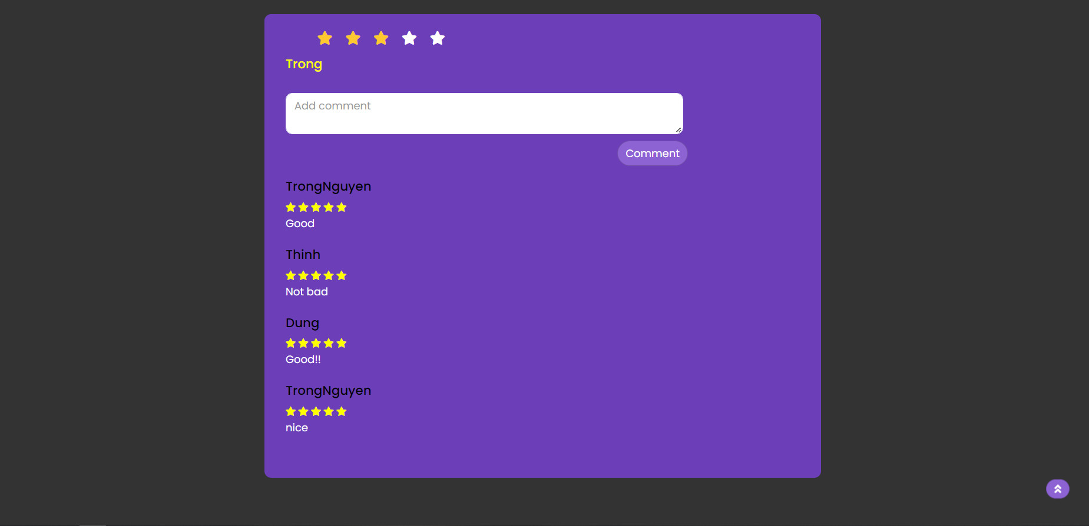

Enter comment

Submit commnent

User commented and rated

Image product

Search for product

Logo website

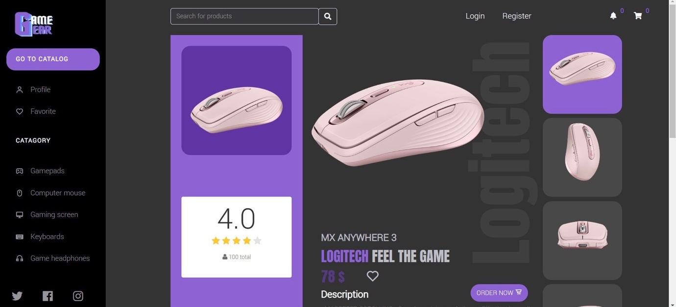

Product detail photos

Name product

Add to wishlist

Total Star rating

Add to cart

Number of reviewers

Price product

## 

Enter Email

Enter Password

Forgot Password

Submit login

Login with Facebook – GitHub - Google

## 

Selected Product

Enter name

Enter email

Enter phone number

Transport fee

Total Price

Address Details

Row address

## 

Send email product purchase notice

Price Product

Transport fee

Total Price

## 

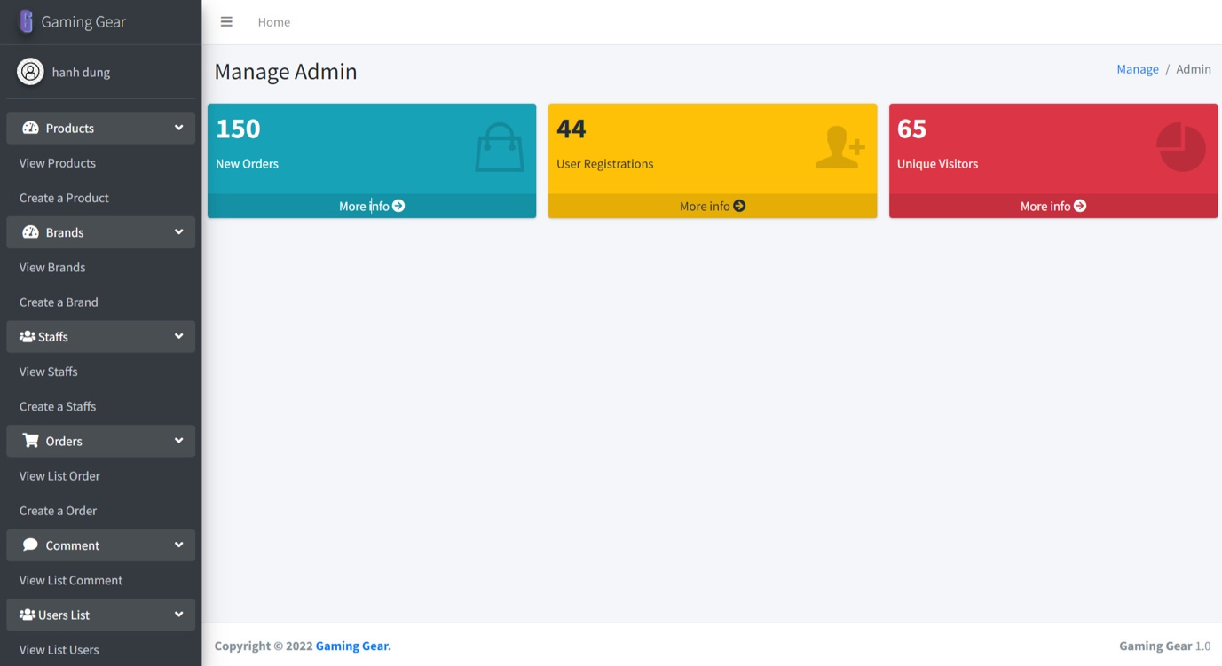



## TASK SHEET REVIEW 3

|  |  |  |  |  |  |  |  |
| --- | --- | --- | --- | --- | --- | --- | --- |
| **Project: Game Gear** | | **Project Name** | **Activity Plan Prepared By** | **Date of Preparation of Activity Plan:** | | | |
| **No** | **Task** | **Actual Start Date** | **Actual Days** | **Team member name** | **Status** |
| **1** | **Database Design** | **Game Gear** | **Trọng** | 08-Jun-22 | 30 | Thịnh | Completed |
| **2** | **Front-end layout** | 08-Jun-22 | 1 | Thái/Thuận | Completed |
| **3** | **Back-end layout** | 08-Jun-22 | 1 | Thịnh/Thái | Completed |
| **4** | **Admin dashboard** | 08-Jun-22 | 30 | Thuận | Completed |
| **5** | **CRUD – order, order-item, product, user, staff, authorizations, transport** | 08-Jun-22 | 30 | Thái | Completed |
| **6** | **CRUD – post, post_comment** | 08-Jun-22 | 3 | Trọng | Completed |
| **7** | **CRUD – brand, category, image_item, comment, coupon** | 08-Jun-22 | 3 | Thuận/Thái/Trọng | Completed |
| **8** | **Home page** | 08-Jun-22 | 1 | Thái/Thịnh | Completed |
| **9** | **Products** | 08-Jun-22 | 1 | Thái | Completed |

|  |  |  |  |  |  |  |  |
| --- | --- | --- | --- | --- | --- | --- | --- |
| **10** | **Product detail page** |  |  | 08-Jun-22 | 1 | Thái | Completed |
| **11** | **Login/Register** | 08-Jun-22 | 1 | Dung | Completed |
| **12** | **Cart** | 08-Jun-22 | 2 | Thịnh | Completed |
| **13** | **Checkout** | 08-Jun-22 | 2 | Thịnh | Completed |
| **14** | **Wishlist** | 08-Jun-22 | 1 | Trọng | Completed |
| **15** | **About us** | 08-Jun-22 | 1 | Thuận | Completed |
| **16** | **Contact us** | 08-Jun-22 | 1 | Trọng | Completed |
| **17** | **User Account** | 08-Jun-22 | 1 | Dung | Completed |
| **18** | **Purchase history** | 08-Jun-22 | 1 | Dung | Completed |
| **19** | **Content Collection** | 08-Jun-22 | 1 | Trọng | Completed |
| **20** | **UI/UX testing** | 08-Jun-22 | 30 | Trọng/Thái/Thịnh/  Dung/Thuận | Completed |

**Date: 22 Jun 2022**

|  |  |
| --- | --- |
| **Signature of Instructor:**  **Ms. Le Mong Thuy** | **Signature of Team Leader:**  **Nguyen Tran Trong** |